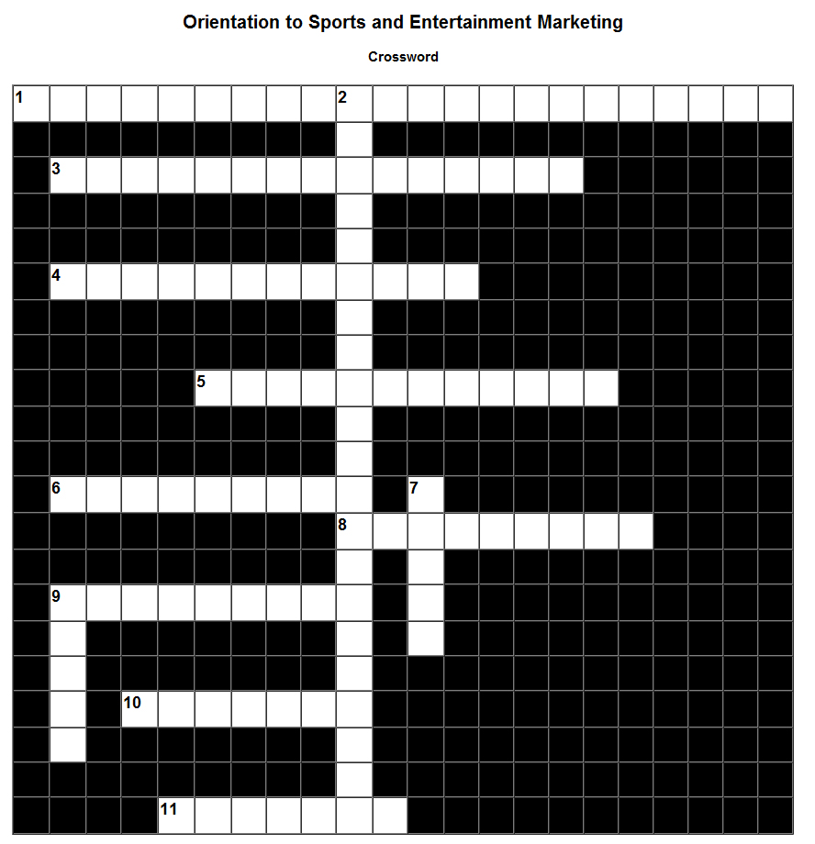
Across: | Down:
1) Promoting products, or goods and services, to satisfy customer’s needs and wants through entertainment. | 2) Identifying groups of consumers based on their common needs.
3) The act of using sports as a platform to market products or services to increase sales. | 7) What customers are willing to pay and production costs.
4) Determining how best to get products and services to customers. | 9) Marketing the product to the customer.
5) Information provides descriptive classifications of consumers.
6) Creating a budget for a company’s marketing plan.
8) Developing, promoting, and distributing products, or goods and services to satisfy customer’s needs and wants.
9) Marketers determine which promotional methods will be most effective.
10) Goods, services or ideas used to satisfy consumer needs, designed and produced on the basis of consumer needs and wants.
11) Communicating with consumers to assess and fill their needs, as well as anticipating future needs.

