Name: ____________________ Date: ___________

MARKETING MIX FOR SEM

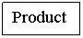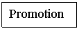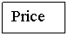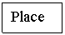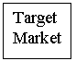

Directions: Choose a company that is related to the sports and entertainment industry. No company can be duplicated so make sure to get approval. You will then identify that company’s marketing mix utilizing all you have learned about the 4 Ps. Be prepared to share!

Review (Give brief/general description of each):

Marketing Mix:

Product:

Price:

Place:

Promotion:

Company you picked: ______________________________________________

Company’s Marketing Mix (make sure to elaborate and use examples)

Product:

Price:

Place:

Promotion:

