Name: __________________________ Date: _____________

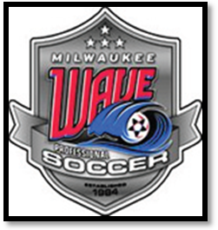
Milwaukee Wave Ticket Case Study

The Milwaukee Wave, members of the National Professional Soccer League (NPSL), had averaged 7,903 fans per game in 1997. In just one year, the franchise was able to boost their 1998 average to almost 8,500
fans, or 11,000 more fans over the course of the season than the previous year.

That attendance increase was due, in large part, to a single promotion aimed at driving paid attendance. The promotion did not come without a cost. The Wave marketing team opted to hire Green Bay Packers quarterback Brett Favre to appear during halftime of a Wave home game. Favre collected $75,000 --
more than the annual salary of all but one Wave player, for his brief Bradley Center appearance.

The promotion, however, generated a league record attendance of 18,197 (the mark remains the largest single-game crowd in league history). Fans paid between $12 and $16 per ticket. Assuming fans paid an average of $14 per ticket, the team successfully generated nearly $255,000 in ticket sales revenue. In addition, the promotion surely amplified merchandise, concessions and parking revenues. The promotion also put the team in the spot light, helping it attract new sponsors. The Wave has since been in the league’s top three in paid attendance every season.

Case Study Questions
1.) Do you think the Milwaukee Wave’s promotion was effective?

Why or why not?

2.) Aside from the direct results associated with the promotion, how do you think Brett Favre’s
Appearance impacted future ticket sales?

How and why?

