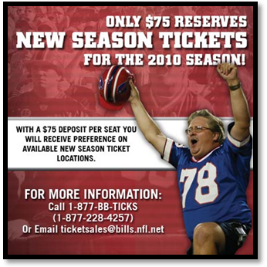
Ticket Promotion and Sales
Ticketing Activity

Student Name ____________________

Directions: Using the Internet, Perform a search to find a sports or entertainment property’s website link to their ticket sales and promotion page.

Carefully review the packaging strategy the organization has implemented and answer the questions below.

1) What organization did you research?

2) Is it a sports or entertainment property?

3) Do you think a difference in strategy exists between sports properties and entertainment properties?

Why or why not?

4) What types of packages are being offered?

5) Does the organization offer any noticeable price adjustments for different packages? Why do you think this is or isn’t the case? Explain your answer in detail.

6) What do we mean by the term “season ticket equivalents”?

7) Do you think any sports or entertainment properties choose NOT to offer ticket packages outside of full season plans? Find an example online.

