From where in the world did my clothes come?

You and two partners are to complete the following activities:

- Determine where at least 8 items of clothing, accessories, etc which you are wearing today was manufactured. List the locations below:
___________________________________________________________
___________________________________________________________
___________________________________________________________
___________________________________________________________
___________________________________________________________
___________________________________________________________
___________________________________________________________
___________________________________________________________

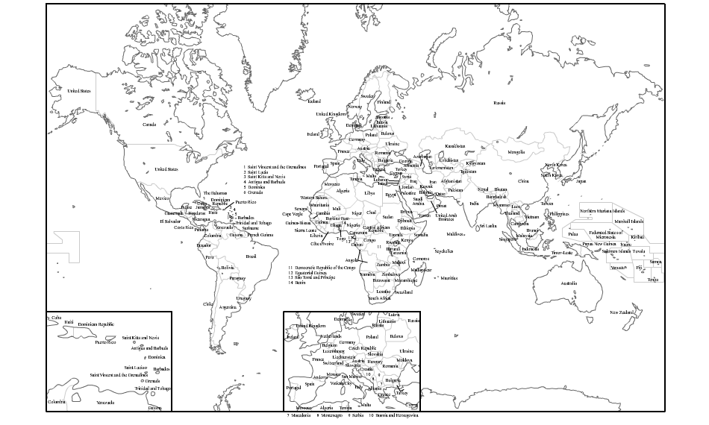
- Use the map below to indicate the source of each of your fashion items listed above;

- Select one of items listed above and complete a creation timeline for the item. You will need to research the manufacturing process of the item to determine needed information. You will also need to look at the fiber make-up of the item to determine where the creation process originally started. Use the attached timeline to describe a hypothetical creation process for your selected item, but remember it must be manufactured in the country where the tag indicates and be made by the material the tag indicates. At each stage of the timeline you should include the following:
- location
- labor needs
- materials
- how transported to the location
- process which is being done to the creation of the item

- Be prepared to discuss your timeline with the class.

