World of Fashion Test Name: ____________________________

Read the statement and determine if the statement is true or false. Select the best answer by writing “true” or “false” in the blank next to the number. Questions answered with just a T or F will be marked incorrect regardless of the answer. (Point Value: 1 pt each)

_________ 1. Texture is defined as the color and weight of a fabric.
_________ 2. Christian Dior was the designer credited with the creation of the “New
Look.”
_________ 3. The Grunge Look is an example of a fashion trend following the Trickle
Down Theory of Fashion Movement.
_________ 4. The marketing mix is product, place, position, and price.
_________ 5. The American Marketing Association defines marketing as “planning
and executing the conception, pricing, promotion, and distribution of
ideas.”
_________ 6. Young Designer describes garments that are targeted towards a younger
audience and created by a well-established designer.
_________ 7. Classic styles are short lived fashions.
_________ 8. The fashion life cycle is defined as the time period a fashion is in style.
_________ 9. Selling is the main function of marketing.
_________ 10. Promotion is communicating with customers about products for sale.
_________ 11. Dandyism is defined as a style of dress for women from the 1800’s that
celebrated a lifestyle of elegance and refinement.
_________ 12. Gabrielle “Coco” Chanel was one of the most influential designers of the
20th century.

Each of the following sentences is missing one or two words. Read each sentence and in the black provided, write the word(s) that would correctly complete the sentence. (Point Value: 1 pts each)

13. ________________________ is the French term meaning high-fashion, individually designed, original, handmade garments.
14. ____________________ was known as an influencer of fashion in the 16th century.
15. The _________________________ of the 1970’s was an organized effort to establish equal social, economic, and political rights and opportunities for women.
16. The _____________________ need satisfied by clothing offers protections and safety.
17. Jackie Kennedy Onassis influenced fashion with a trademark _____________ hat.
18. Christian Dior introduced the ____________________ in the 1940’s.
19. The Beatles influenced fashion with their hairstyles known as __________________.
20. ______________________ is credited with the look called “Dandyism.”

Answer the following questions. Write your answers in the space provided below the question. (Point Value: 2 pts each)

21. What is the term used to describe young, independent-minded and free-spirited women who wore shorter hemlines and short hairstyles during the 1920’s?

22. What is the term used to describe a style introduced in the 1950’s characterized by long hemlines, narrow shoulders, and tightly fitted bodices with long, full, or narrow skirts?

23. What is the term used to describe intentionally torn clothing worn by young people that often utilized chains, safety pins, damaged prints that first became a fashion trend in the late 1970’s?

24. Name three needs satisfied by clothing.

25. What fashion trends emerged in the 1980’s?

Match the terms on the left with the correct statements on the right. Write the matching letter in the blank next to the numbers on the left. (Point Value: .5 pt. each)

______ 26. Color A. overall form or outline
______ 27. Design B. the brightness or dullness of a color
______ 28. Texture C. the quality of the color
______ 29. Shape D. directs the path of eye movement
______ 30. Intensity E. unique version of a style
______ 31. Garment F. most important element of design
______ 32. Hue G. the feel and look of a fabric’s surface
______ 33. Line H. any article of clothing
______ 34. Style I. unique version of a style
______ 35. Design J. particular shape of apparel item

Read the questions below. Select the once best answer from the choices listed under the question and write the letter in the blank next to number of the question. You will not be given any credit for questions answered by circling the letters rather than writing answers in the blanks provided. (Point Value: 2 pts each)

______ 36. This French King sent life-sized dolls to other royal courts to demonstrate
the proper fashion of the day:
A. Louis XV
B. Louis XIV
C. King Author
D. Louis XVI

_______ 37. The “Mop-Top” Hairstyle is credited to a British band from the early
1960’s called:
A. The Beatles
B. The Monkeys
C. Pink Floyd
D. The Rolling Stones

_______ 38. During the 18th century, the Queen of France that used white papier-mâché
paste to whiten and stiffen her hair to extreme heights was:
A. Cleopatra
B. Eleanor of Aquitaine
C. Isabella
D. Marie Antoinette

________ 39. Judi buys a pair of jeans from Abercrombie and Fitch paying $85 for the
jeans. Judi does not really care for the jeans, but all of her friends are
wearing this style. Which of Judi’s needs is being met with this purchase?
A. Emotional
B. Physical
C. Psychological
D. Social

________ 40. The best example of a recent fad is:
A. Boot Cut Jeans
B. Halter Tops
C. Rubber bracelets with slogans
D. Tennis Shoes

________ 41. Product mix refers to:
A. Encouraging customers to purchase products.
B. Buying only designer apparel.
C. Creating and maintaining designer collections.
D. The selection of styles, product classifications, and price lines.

________ 42. Some of the ways to classify garments by function include:
A. Denim, silk, cotton, and nylon.
B. Sportswear, activewear, eveningwear, and careerwear.
C. Shoes, hats, coats, and gloves.
D. Retail, wholesale, designer, and fad.

________ 43. When a garment is part of a trend, it means:
A. It is a luxury item.
B. It is classified as a couture fashion.
C. It would make a great gift.
D. The item reflects the direction of fashion.

________ 44. Assisting in the design and development of new products is:
A. Product/service management
B. Financing
C. Market-information management
D. None of the above.

________ 45. Advertising a garment in a magazine is an example of:
A. Promotion
B. Product/service management
C. Purchasing
D. None of the above.

_______ 46. The phase when sales of a fashion item are at the highest level is:
A. A fad
B. The peak phase
C. The fast track
D. The classic

_______ 47. Some of the most common styles are:
A. Trendy
B. Classic
C. Designer
D. All of these

_______ 48. Three phases of the fashion life cycle are:
A. Introductory, peak, and decline
B. Design, construction, and distribution.
C. Price, product, and promotion.
D. None of the above.

_______ 49. Generally the colors and styles worn by people in the United States reflect:
  - Economic conditions and attitudes.
  - With they think looks good on them.
  - Their age and income
  - What is on sale

_______ 50. Marketing, as a business function, is:
- Encouraging customers to purchase products.
- Another term for grocery shopping.
- Creating and maintaining satisfying exchange relationships.
- None of the above.

Label the parts of the picture by filling in the grey boxes next to each number. (Point Value: 2 pts each for a total of 20 points)

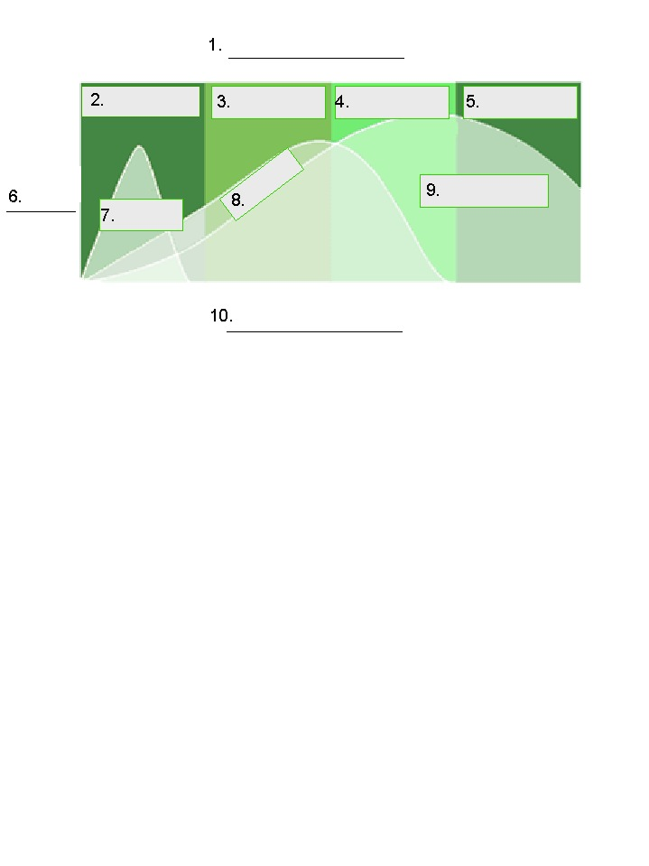

Answer the following questions. Grammar and spelling will count as part of your grade. (Point Value: 10 pts each)

How did World War II affect the fashion industry? (Hint: In order to answer this question you must think about the economy at the time of the war, the changing workforce, etc)

How do economic and socioeconomic conditions affect fashion? Give at least two specific examples of the affect of economics or socioeconomics on the fashion movement.

Describe 5 techniques you can use to enhance your presentation skills.

