IF I WERE AN ARTICLE OF CLOTHING
Students will write a 3-5-paragraph essay to complete the following statement.
“If I were an article of clothing, I would be…”
Included in this essay must be a detailed description of what the article of clothing looks like, the characteristics of the article of clothing which are similar to your characteristics as a person, and how you would spend your day as this article of clothing. (What would you do? where would you go?)
Each paragraph must be at least 5 sentences in length.
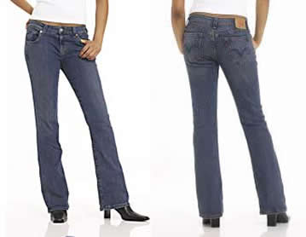
Example:
If I were an article of clothing, I would be a pair of indigo sandblast Levi´s Super Low Boot Cut Jeans. I have a flirty low-rise styling in slim-fitting stretch denim with a 32” inseam. Notice my classic five-pocket styling and button fly. I am made of the best denim fabric known to mankind, cotton/lycra spandex. I am machine washable.
I am everyone’s favorite thing to wear and am extremely versatile since I can be dressed up or down. I promise to always make you look good. I even make you happy when you feel like you’ve gained ten pounds. I make you look sexy when you go on a date. I am a classic. I will never go out of style. My owner will wear me every week, until the brink of death when I am faded and my inseam is falling apart.
A day in my life would be spent in Nordstrom’s. A pretty, young Marketing teacher would spot me from across the store. Yes! I am her size, but do I fit her? She takes me to the dressing room for the dreaded trying on process. A perfect fit! She admires me in the mirror. Or is she admiring herself? Yeah, I make her look good and she knows it. She doesn’t even take me off. She walks up to the cashier in the jeans department. All the other jeans are jealous because she picked me. No one has ever been worn out of the store before, that is, until now. After she pays for me and walks away from the cashier, he checks her out. No, wait, he’s not checking her out, he’s admiring the detailed stitch on my back pockets. He’s checking me out! Hey, slow down Marketing teacher. What’s the hurry? If he wants to look, let him. She stops. Now’s my chance. Hey babe, what’s your name?

