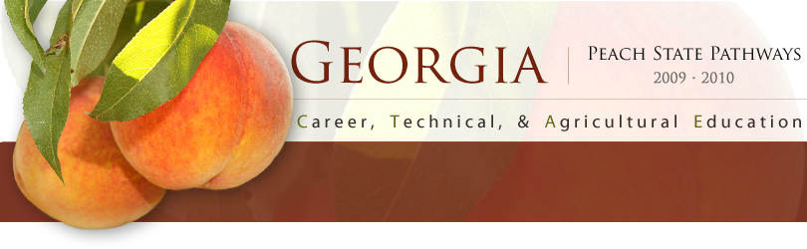

Marketing Sales and Service

PATHWAY: Fashion Marketing
COURSE: Introduction to Fashion Marketing
UNIT 11: Careers in the Fashion Industry

Introduction

Annotation:
This unit allows students to explore career options in the fashion industry. Students will look at personal characteristics as well as skills and education needed to be successful in the fashion industry.
Grade(s):
x | 9th
x | 10th
x | 11th
x | 12th

Time: 6 50 min periods
Author: Rachael McClain
Additional Author(s):
Students with Disabilities:
For students with disabilities, the instructor should refer to the student's IEP to be sure that the accommodations specified are being provided. Instructors should also familiarize themselves with the provisions of Behavior Intervention Plans that may be part of a student's IEP. Frequent consultation with a student's special education instructor will be beneficial in providing appropriate differentiation.

Focus Standards
GPS Focus Standards:
MKT-FM-11. Students will identify career opportunities in the fashion
industry and appropriate career path credentials.

- Compare career opportunities and skill requirements for jobs in fashion marketing at the manufacturing, wholesaling, and retailing levels.
- Describe the aptitudes and skill requirements for career sustaining and mid-level management positions in fashion marketing.
- Research post-secondary opportunities to prepare for a career in the fashion industry.
- List and describe professional organizations in the field of fashion.

GPS Academic Standards:
ELA11W3. The student uses research and technology to support writing.

National / Local Standards / Industry / ISTE:

Understandings & Goals
Enduring Understandings:

- The student will understand career options in the fashion industry by investigating post-secondary requirements, experience, and job outlook.
- The student will understand the personal traits needed to be successful in a career in the fashion industry.

Essential Questions:

- What are viable career options for me in the fashion industry?
- What are the experience and education requirements to be successful in a chosen career in the fashion industry?

Knowledge from this Unit:
- A wide range of career options are available in the fashion industry.
- Careers in the fashion industry require a wide range of education and experience with career options ranging from no additional education after high school to post-secondary degrees plus experience.

Skills from this Unit:
- The student will conduct a detailed analysis of a career options in the fashion industry by researching actual careers available at the current time.
Assessment(s)
Assessment Method Type:
 | Pre-test
 | Objective assessment - multiple-choice, true- false, etc.
__ Quizzes/Tests
__ Unit test
 | Group project
x | Individual project
 | Self-assessment - May include practice quizzes, games, simulations, checklists, etc.
__ Self-check rubrics
__ Self-check during writing/planning process
__ Journal reflections on concepts, personal experiences and impact on one’s life
__ Reflect on evaluations of work from teachers, business partners, and competition judges
__ Academic prompts
__ Practice quizzes/tests
 | Subjective assessment/Informal observations
__ Essay tests
__ Observe students working with partners
__ Observe students role playing
 | Peer-assessment
__ Peer editing & commentary of products/projects/presentations using rubrics
__ Peer editing and/or critiquing
 | Dialogue and Discussion
__ Student/teacher conferences
__ Partner and small group discussions
__ Whole group discussions
__ Interaction with/feedback from community members/speakers and business partners
 | Constructed Responses
__ Chart good reading/writing/listening/speaking habits
__ Application of skills to real-life situations/scenarios
 | Post-test

Assessment(s) Title:
Fashion Marketing Career Portfolio
Career Plan & Information Sheet
Retail Professional Interview

Assessment(s) Description/Directions:
See attached descriptions and rubrics
Learning Experiences

Sequence of Instruction
- Identify the Standards. Standards should be posted in the classroom for each lesson.
MKT-FM-11. Students will identify career opportunities in the fashion
industry and appropriate career path credentials.

- Compare career opportunities and skill requirements for jobs in fashion marketing at the manufacturing, wholesaling, and retailing levels.
- Describe the aptitudes and skill requirements for career sustaining and mid-level management positions in fashion marketing.
- Research post-secondary opportunities to prepare for a career in the fashion industry.
- List and describe professional organizations in the field of fashion.
ELA11W3. The student uses research and technology to support writing.

- Review Essential Questions.
  - What are viable career options for me in the fashion industry?
  - What are the experience and education requirements to be successful in a chosen career in the fashion industry?
- Identify and review the unit vocabulary.
- “If I were an article of Clothing” activity
- Career Portfolio
  - Fashion Marketing Career Portfolio
  - Fashion Show for Career Dressing
  - Career Grading Rubric
  - Retail Professional Interview Questions
- Student Presentations
Attachments for Learning Experiences:

Notes & Reflections:
Encourage students to explore all levels of fashion careers from primary and secondary markets to tertiary markets and support industries.

Culminating Performance Task(s)
Culminating Unit Performance Task(s):
Culminating Unit Performance Task Description/Directions/Differentiated Instruction:
Unit Resources
Web Resources:
http://www.careercruising.com/
Attachments, Materials & Equipment:
Computers with Internet access
Extra Resources:
Catch a Career Activity and Rubric

What 21st Century Technology was used in this Unit:
Top of Form
x | Slide Show Software |  | Graphing Software |  | Audio File(s)
 | Interactive Whiteboard |  | Calculator |  | Graphic Organizer
 | Student Response System |  | Desktop Publishing |  | Image File(s)
 | Web Design Software |  | Blog |  | Video
 | Animation Software |  | Wiki |  | Electronic Game or Puzzle Maker
 | Email | x | Website
Bottom of Form

