Name: __________________________________________

Cut samples of types of materials matching the weave or knit patterns below based upon your observations in the classroom while using the microscopes. Select a fabric that most closely represents the patterns below.

Fabric Sample:
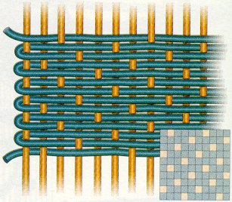

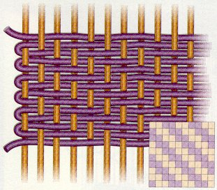

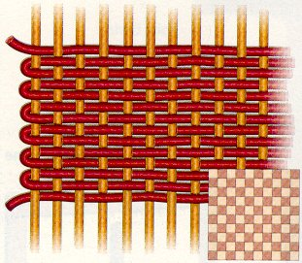

Fabric Sample:

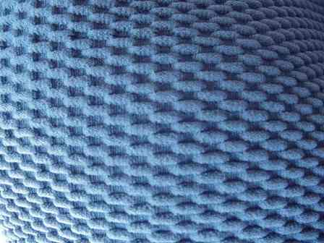

Textures Exercise:

Select three fabric samples that would cause the wearer to appear larger:

Select three fabric samples that would cause the wearer to appear slimmer:

