Fashion Capitals
Name________________________________________
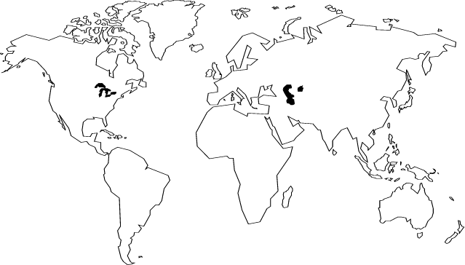
List the 5 fashion capitals and mark them on the map. Also list two designers from each capital.
1.

2.

3.

4.

5.

