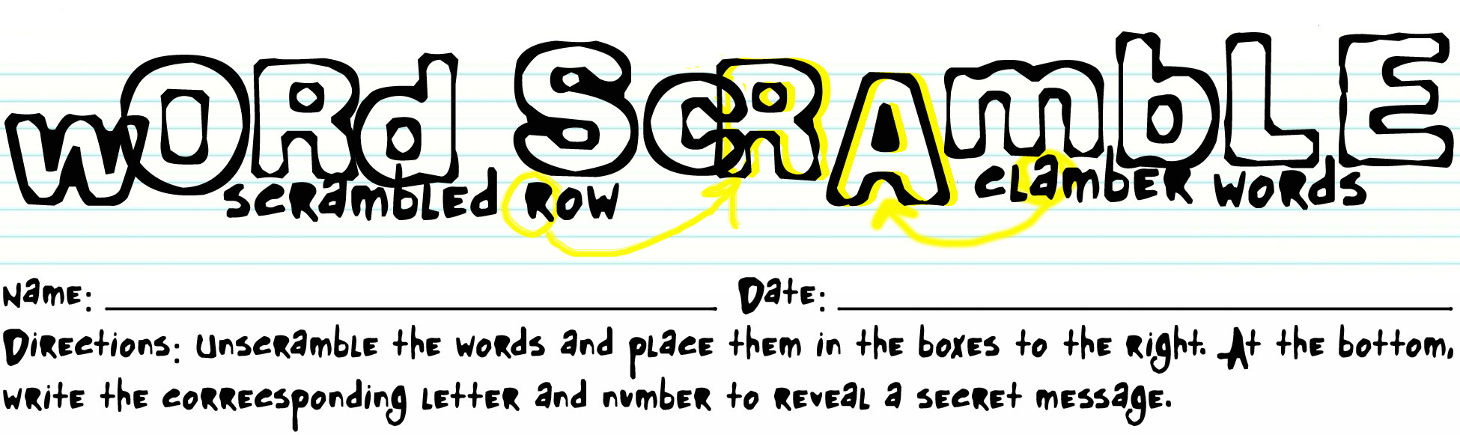

owollf pu
To take further actions remaining after an event. |  |  |  |  | 2

ctctonsa
People who act as sources of information or data. |  | 6 |  |  |  |  |  | 15

ngiowrnek
Process of making connections with people in the work world. |  |  |  | 1

remtsuco lerreefrsa
The act of recommending a store to another individual. |  |  | 14 |  |  |  |  | 3 |  |  |  | 7

lbaerdr dogos
Consumer goods that are not destroyed by use. |  |  |  |  |  | 8 | 4

xddeeetn ararwnyt
Prolonged contract which protects the owner against the malfunctioning of a purchased object. |  |  |  |  |  | 5

ugestginos gillsen
Technique of persuading the customer to purchase additional items to go with merchandise requested by a customer |  | 9 |  |  |  |  |  | 11 |  |  |  |  | 13

ponecendesrroec
Any form of written communication sent or received in the course of affairs, including letters, postcards, memoranda, notes, electronic mail, facsimiles, telegrams, or cables. |  |  |  |  |  | 10 |  |  |  |  |  | 12

1 | 2 | 3 | 4 | 5 |  | 6 | 7 |  | 8 | 9 | 10 | 11 | 12 | 13 | 14 | 15

Key

owollf pu | F | O | L | L | O | W |  | U | P
To take further actions remaining after an event. |  |  |  |  | 2

ctctonsa | C | O | N | T | A | C | T | S
People who act as sources of information or data. |  | 6 |  |  |  |  |  | 15

ngiowrnek | N | E | T | W | O | R | K | I | N | G
Process of making connections with people in the work world. |  |  |  | 1

remtsuco lerreefrsa | C | U | S | T | O | M | E | R |  | R | E | F | E | R | R | A | L | S
The act of recommending a store to another individual. |  |  | 14 |  |  |  |  | 3 |  |  |  | 7

lbaerdr dogos | D | U |  | R | A | B | L | E |  | G | O | O | D | S
Consumer goods that are not destroyed by use. |  |  |  |  |  | 8 | 4

xddeeetn ararwnyt | E | X | T | E | N | D | E | D |  | W | A | R | R | A | N | T | Y
Prolonged contract which protects the owner against the malfunctioning of a purchased object. |  |  |  |  |  | 5

ugestginos gillsen | S | U | G | G | E | S | T | I | O | N |  | S |  | E | L | L | I | N | G
Technique of persuading the customer to purchase additional items to go with merchandise requested by a customer |  | 9 |  |  |  |  |  | 11 |  |  |  |  | 13

ponecendesrroec | C | O | R | R | E | S | P | O | N | D | E | N | C | E
Any form of written communication sent or received in the course of affairs, including letters, postcards, memoranda, notes, electronic mail, facsimiles, telegrams, or cables. |  |  |  |  |  | 10 |  |  |  |  |  | 12

W | O | R | L | D |  | O | F |  | B | U | S | I | N | E | S | S
1 | 2 | 3 | 4 | 5 |  | 6 | 7 |  | 8 | 9 | 10 | 11 | 12 | 13 | 14 | 15

