BAND SAW DIAGRAM
Handout

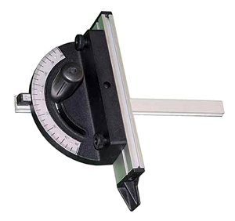
5.
10.
11.
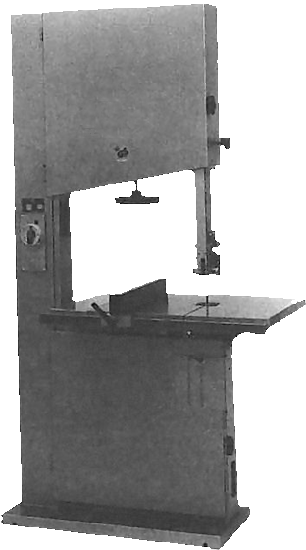
1.
2.
3.
4.
6.
7.
8.
9.
12.

- On/Off Switch | 7. Blade Guard
- Table | 8. Blade Tension Adjustment
- Brake | 9. Upper Guide Assembly
- Adjustable Fence | 10. Upper Wheel Guard Door
- Miter Gauge | 11. Adjustment for Upper Guide Assembly
- Blade | 12. Lower Wheel Guard Door


Diagram recreated by Alison Burkett from information provided by John M. F. Berner

