BAND SAW DIAGRAM
Worksheet
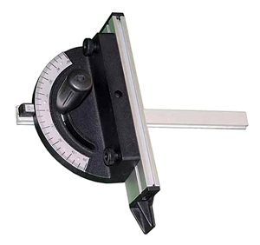
12.
3.
9.
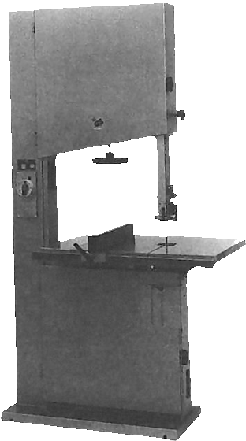
1.
6.
10.
4.
2.
8.
7.
11.
5.

7.
8.
9.
10.
11.
12.


Worksheet created by Alison Burkett from information provided by John M. F. Berner

