Common Square Tool: Combination Square Diagram

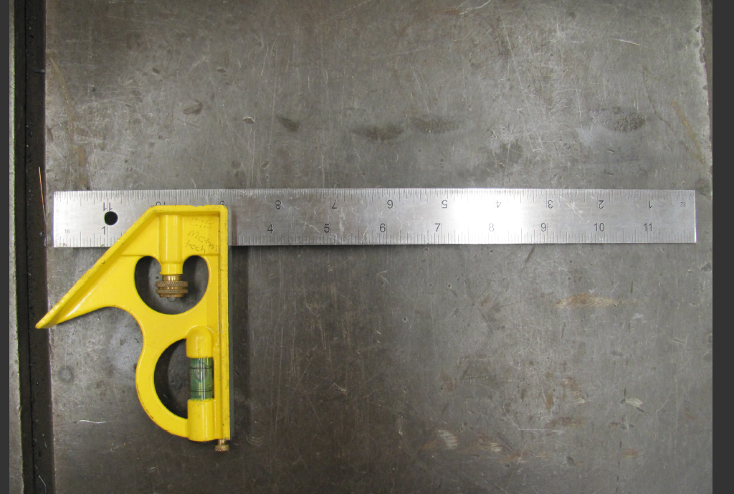

4

2
1

3

- Head:

- Adjustment locking nut:

- Spirit level/ bubble level:

- Blade/ steel rule:


Created by Alison Burkett with information & photo provided by Matt Hayden

