DRILL PRESS DIAGRAM
Handout
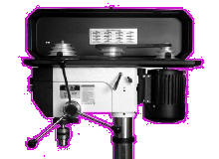
9.
2.
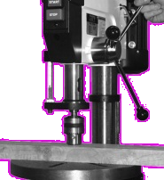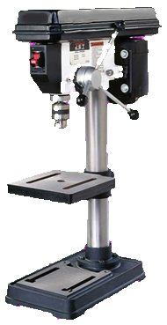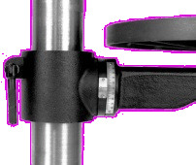
7.
8.
5.
6.
10.
3.
3.
1.
4.
1.

- Power Switch
- Safety Guard
- Depth Stop
- Table Locking Clamp
- Index Pin
- Key Chuck
- Table
- Column
- Speed Adjustment
- Universal Feed Lever



