Constructing Angles

Name: ____________________________Date: ______

- Constructing a 90-degree, or right, angle is not difficult if you have a true, steel square. Suppose that you have no square or that your square is off and you need a right angle for a layout. Breakout your dividers, a scriber, and a straightedge, then draw a base line like the one labeled AB in the picture below:

A
B
C
D
Constructing a 90-degree angle by bisecting a line

Set the dividers for a distance greater than one-half AB; then, with A as a center, scribe arcs like those labeled C and D. Next, without changing the setting of the dividers, use B as a center, and scribe another set of arcs at C and D. Draw a line through the points where the arcs intersect and you have erected perpendiculars to line AB, forming four 90-degree, or right, angles. You have also bisected or divided line AB into two equal parts.

- Constructing a right angle at a given point with a pair of dividers is a procedure you will find useful when making layouts. Imagine that you have line XY with A as a point at which you need to fabricate a perpendicular to form a right angle. Select any convenient point that lies somewhere within the proposed 90-degree angle. In picture below that point is C.

• C
D
X
Y
A
B
Constructing a 90-degree angle at a given point

Using C as the center of a circle with a radius equal to CA, scribe a semicircular arc, as shown in the picture above. Lay a straightedge along points B and C and draw a line that will intersect the other end of the arc at D. Next, draw a line connecting the points D and A and you have fabricated a 90-degree angle.

- This procedure may be used to form 90-degree comers in stretch-outs that are square or rectangular, like a drip pan or a box. Laying out a drip pan with a pair of dividers is no more difficult than fabricating a perpendicular. You will need dividers, a scriber, a straightedge, and a sheet of template paper. You have the dimensions of the pan to be fabricated: the length, the width, and the height or depth. Draw a base line.

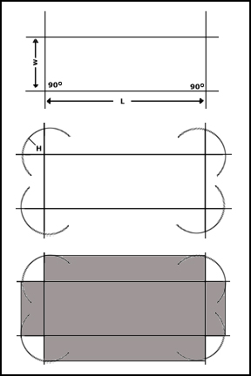

Select a point on this line for one comer of the drip pan layout. Erect a perpendicular through this point, forming a 90-degree angle. Next, measure off on the base line the required length of the pan. At this point, erect another perpendicular. You now have three sides of the stretch-out. Using the required width of the pan for the other dimensions, draw the fourth side parallel to the base line, connecting the two perpendiculars that you have fabricated.

- Now, set the dividers for marking off the depth of the drip pan. You can use a steel scale to measure off the correct radius on the dividers. Using each comer for a point, swing a wide arc. Extend the end and sidelines and complete the stretch-out by connecting the arcs with a scriber and straightedge.

Bisecting an arc is another geometric construction that you should be familiar with. Angle ABC is given.

A
E
F
C
D
B
Bisecting an Arc

With B as a center, draw an arc cutting the sides of the angle at D and E. With D and E as centers and a radius greater than half of arc DE, draw arcs intersecting at F. A line drawn from B through point F bisects angle ABC. Two methods used to divide a line into a given number of equal parts. When the method shown in view A is to be used, you will need a straightedge and dividers. In using this method, draw line AB to the desired length. With the dividers set at any given radius, use point A as center and scribe an arc above the line. Using the same radius and B as center, scribe an arc below the line as shown. From point A, draw a straight line tangent to the arc that is below point B. Do the same from point B. With the dividers set at any given distance, start at point A and step off the required number of spaces along line AD using tick marks-in this case, six. Number the tick marks as shown. Do the same from point B along line BC. With the straightedge, draw lines from point 6 to point A, 5 to 1, 4 to 2, 3 to 3, 2 to 4, 1 to 5, and B to 6. You have now divided line AB into six equal parts.

- When the method shown in view B of the picture below is used to divide a line into a given number of equal parts, you will need a scale.

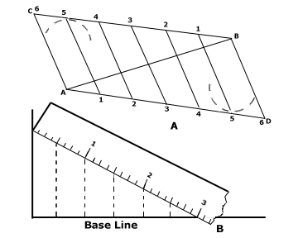
In using this method, draw a line at right angles to one end of the base line. Place the scale at such an angle that the number of spaces required will divide evenly into the space covered by the scale. In view B of the picture, the baseline is 2 1/2 inches and is to be divided into six spaces. Place the scale so that the 3 inches will cover 2 1/2 inches on the base line. Since 3 inches divided by 6 spaces = 1/2 inch, draw lines from the 1/2-inch spaces on the scale perpendicular to the base line. Incidentally, you may even use a full 6 inches in the scale by increasing its angle of slope from the baseline and dropping perpendiculars from the full-inch graduation to the base line.

- To divide or step off the circumference of a circle into six equal parts, just set the dividers for the radius of the circle and select a point of the circumference for a beginning point. In picture below, point A is selected for a beginning point. With A as a center, swing an arc through the circumference of the circle, like the one shown at B in the illustration. Use B, then, as a point, and swing an arc through the circumference at C. Continue to step off in this manner until you have divided the circle into six equal parts. If the points of intersection between the arcs and the circumference are connected as shown in figure 2-13, the lines will intersect at the center of the circle, forming angles of 60 degrees.

If you need an angle of 30 degrees, all you have to do is to bisect one of these 60 degree angles by the method described earlier in this chapter. Bisect the 30-degree angle and you have a 15-degree angle. You can construct a 45-degree angle in the same manner by bisecting a 90-degree angle. In all probability, you will have protractor to lay out these and other angles. But just in case you do not have a steel square or protractor, it is a good idea to know how to construct angles of various sizes and to erect perpendiculars.

Many times when laying out or working with circles or arcs, it is necessary to determine the circumference of a circle or arc.
