One Piece Box Project
Name: Date:
Layout Instructions:
- Cut 1 piece of sheet metal. 4 1/2” x 4 1/2”
- Using a scribe and ruler layout the piece of metal as shown on the drawing below.
- Do all necessary cutting using provided snips or notching equipment.
- Deburr the metal so that there are no sharp edges.
Bending Instructions:
- Bend all 1/4” edges 180 degrees and flatten.
- Bend all 1” lines up 90 degrees.
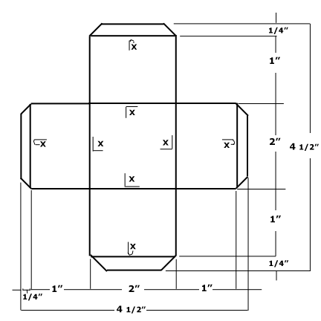
- Make sure your project is deburred and free of all sharp edges.

