Round Edge Box Project
Name: Date:
Layout Instructions:
- Cut 1 piece of sheet metal. 6” X 6”
- Using a scribe, ruler, and divider layout the piece of metal as shown in the drawing below.
- Do all necessary cutting using provided snips or notching equipment.
- Deburr the metal so that there are no sharp edges.
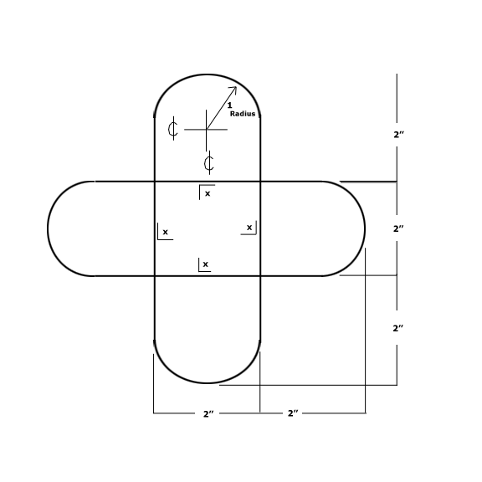
Bending Instructions:
- Bend all lines marked with an X up 90 degrees.
- Make sure your project is deburred and free of all sharp edges.

