Sheet Metal Snips Identification Worksheet
Name: _____________________________ ________Date:

Snips are hand tools used to cut sheet metal. They are also known as shears and can be used to cut more than just sheet metal. Hand snips are important because the shape, construction, location, and position of the work to be cut frequently prevent the use of machine-cutting tools.

In the following, identify the snips. Explain the uses of each pair. This is only a small group of snips that are used in sheet metal working.

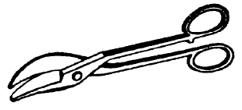
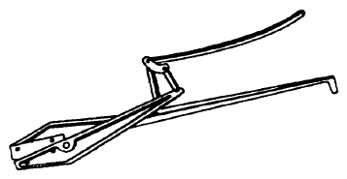

1. 2.
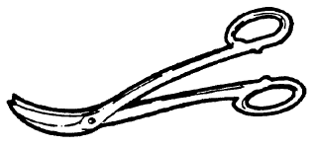
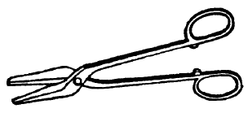

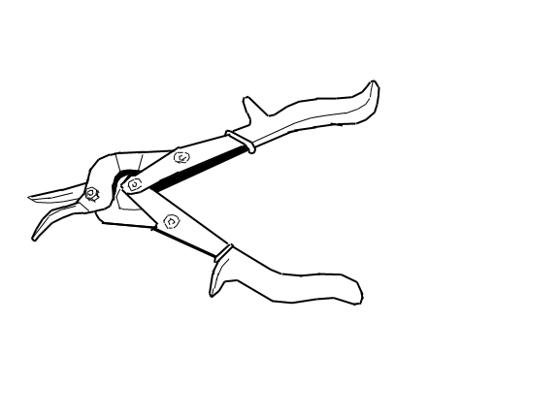
3. 4.
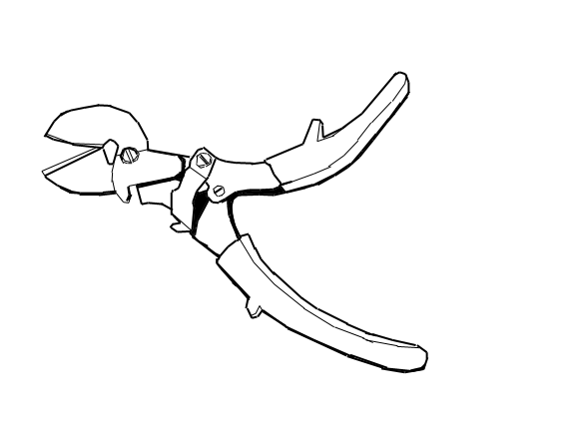
5. 6.
Word Bank:
Hawks-Bill Snips | Circle Snips
Bulldog Snips | Compound Lever Snips
Compound-Action Snips | Offset-Pattern Action Snips

