Sheet Metal Snips Identification
Name: Date:

Snips are hand tools used to cut sheet metal. They are also known as shears and can be used to cut more than just sheet metal. Hand snips are important because the shape, construction, location, and position of the work to be cut frequently prevent the use of machine-cutting tools.

In the following, identify the snips. Explain the uses of each pair.

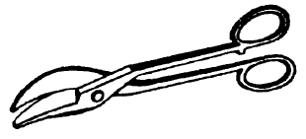
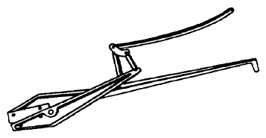

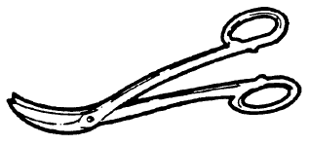
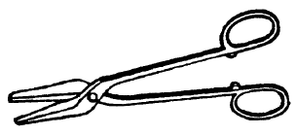

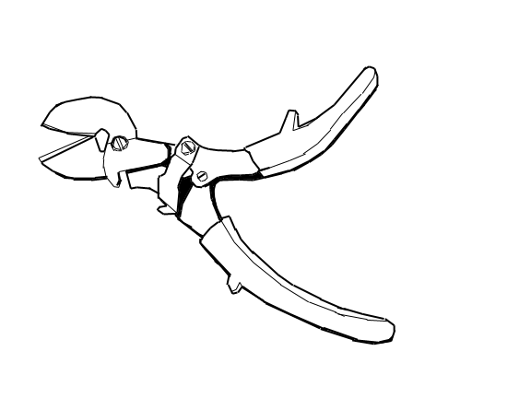
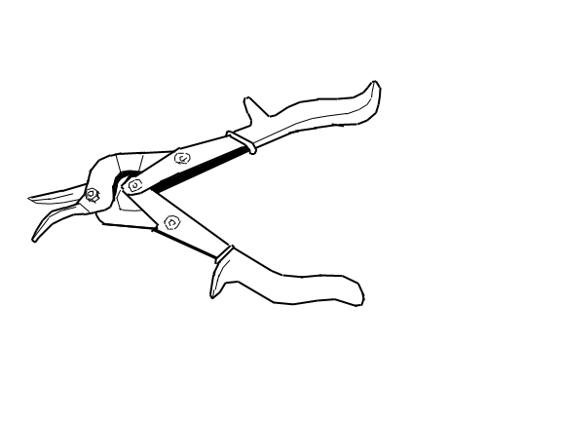

1. Circle Snips – used for making circular cuts
2. Compound Lever Shears – designed to give addition leverage to ease the cutting of heavy metal
3. Hawks-Bill Snips - Used to cut a small radius inside and outside a circle
4. Trojan Snips – Used for straight or curved cutting.
5. Offset Pattern Compound-Action Snips – Also known as Aviation Snips, used to cut harder materials with less effort than other snips/shears.
6. Compound-Action Snips – Also known as Aviation Snips, used to cut harder materials with less effort than other snips/shears.

