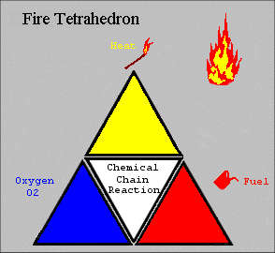
The four elements are oxygen to sustain combustion, sufficient heat to raise the material to its ignition temperature, fuel or combustible material and subsequently an exothermic chemical chain reaction in the material. Each of the four sides of the fire tetrahedron symbolize the Fuel, Heat, Oxygen and Chemical Chain Reaction. Theoretically, fire extinguishers put out fire by taking away one or more elements of the fire tetrahedron.

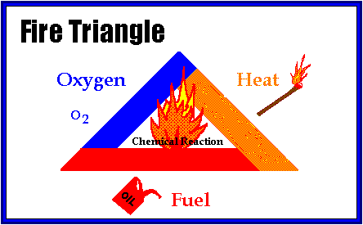

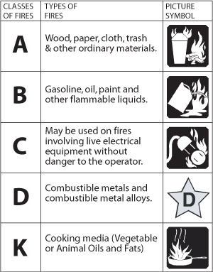

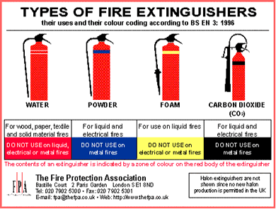

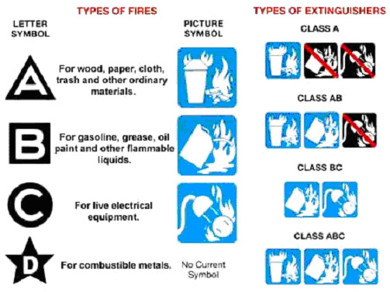

http://www.sxriore.com/s/types+of+fire+extinguisher
http://pictures.augustow.pl/fire-triangle-picture.html
(slide) http://ehs.sc.edu/modules/fire/01_triangle.htm
http://www.firesafe.org.uk/html/miscellaneous/firetria.htm

