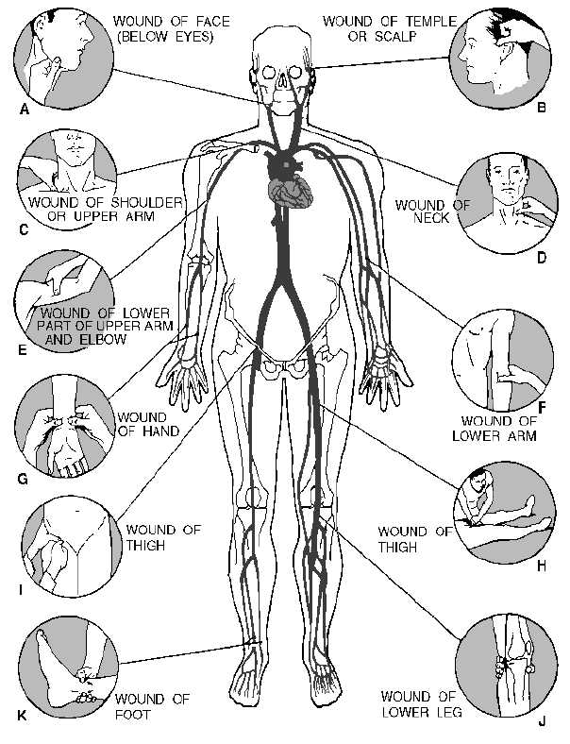
1-11 Figure 1-6.—Pressure points for control of bleeding. You should memorize these pressure points so that you will know immediately which point to use for controlling hemorrhage from a particular part of the body. The correct pressure point is the one that is

http://www.tpub.com/content/neets/14191/css/14191_21.htm

