Name: __________________________

- Out of what material is the part made?
1. ________________________
- What name is given to this part?
2. ________________________
- What number is assigned to the drawing?
3. ________________________
- How are fractional dimensions allowed for?
4. ________________________
- The original drawing is to what scale?
5. ________________________
- What are the dimensions of the part?
6. ________________________
- The block has how many holes drilled into it?
7. ________________________
- Each hole has what diameter?
8. ________________________
- How far is the centerline for the holes from the bottom edge of the part?
9. ________________________
- How far is one hole from the left edge of the part?
10. ________________________
- How far is the other hole from the left edge of the part?
11. ________________________
- How deep are both holes counterbored?
12. ________________________
- What are the dimensions of the shoulder cut in the top surface of the part?
13. ________________________
- Describe the finish on the part given the information given on the drawing.
________________________________________________________________________________________________________________________________________________________________________________________________________________________________________________________________________________________________________________________________________________________________________

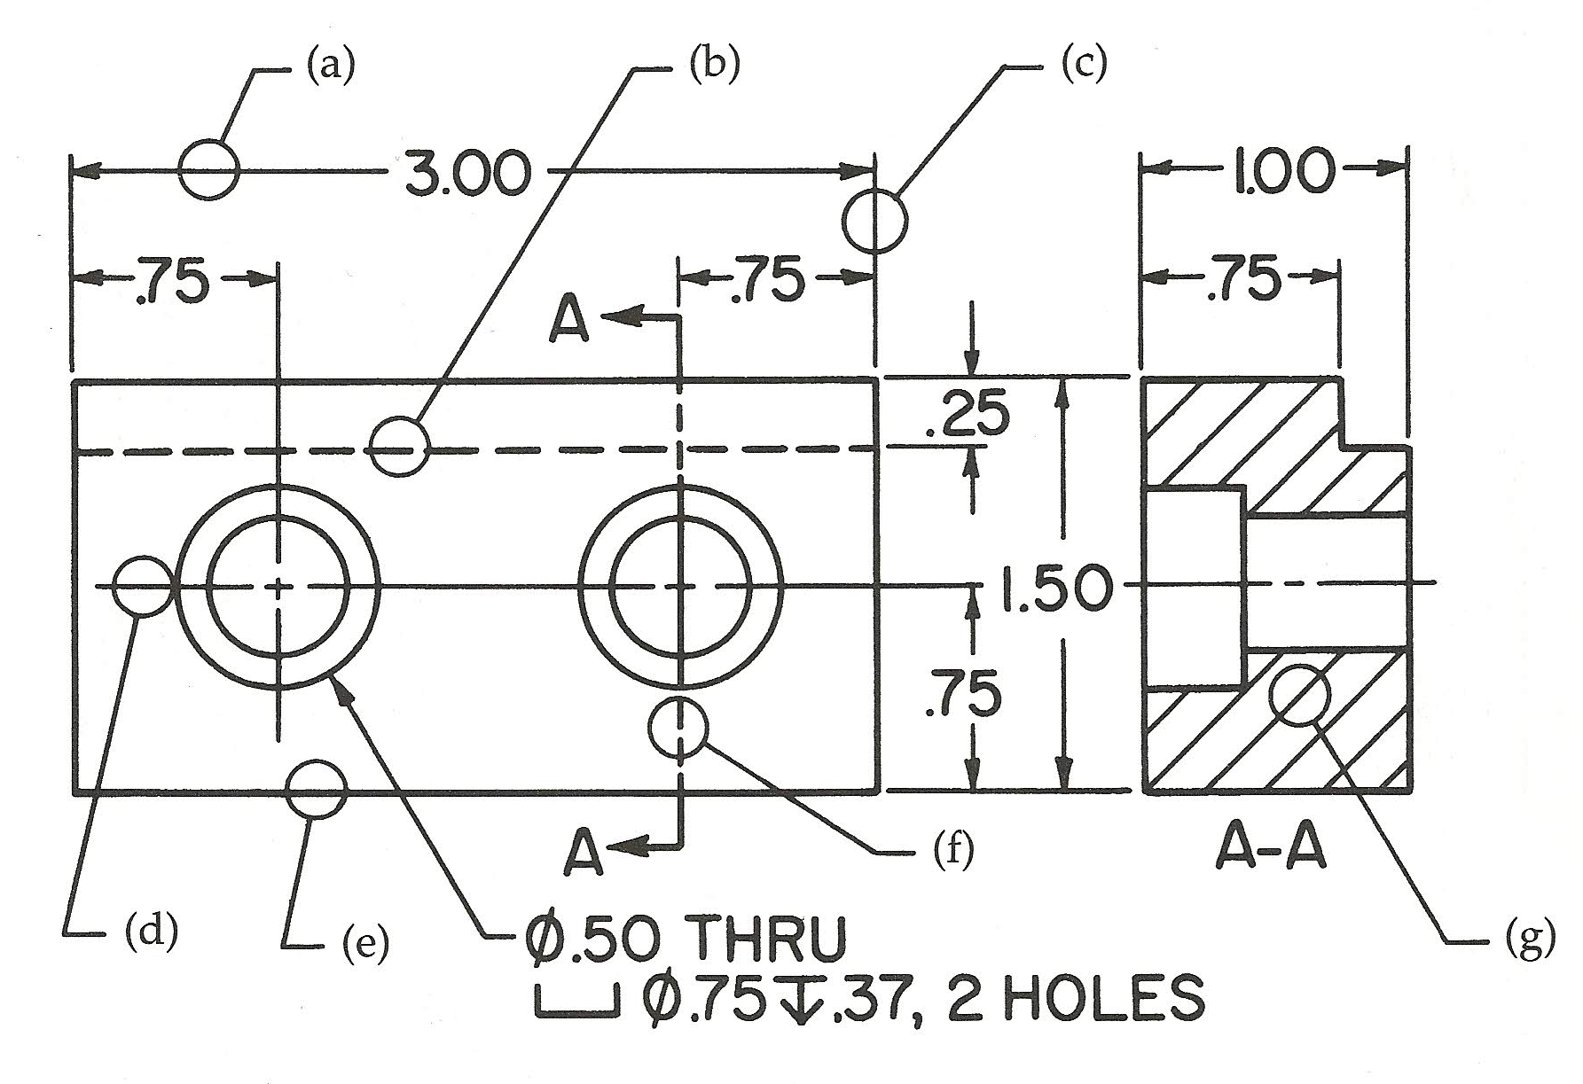

- Identify each part in the diagram.
  - ____________________
  - ____________________
  - ____________________
  - ____________________
  - ____________________
  - ____________________
  - ____________________

