Use of Bench and Pedestal Grinders
What safety procedures should you follow when using bench and pedestal grinders?
- Fasten pedestal and bench grinders securely.
- Ensure all the guards are in place and secure before using a grinder.
- Adjust tool rests to within 3 mm (1/8 in.) of wheels. Never adjust rests while wheels are moving. Work rest height should be on horizontal centre line of the machine spindle.
- Maintain 6 mm (1/4 in.) wheel exposure with a tongue guard or a movable guard.
- Check that wheels have blotters on each side.
- Check the wheel fits properly to the spindle when mounting. If it is loose, get another wheel.
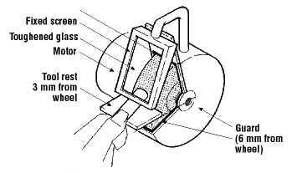
- Stand to one side of the grinder until the wheel reaches operating speed.
- Bring work into contact with the grinding wheel slowly and smoothly, without bumping.
- Apply gradual pressure to allow the wheel to warm up evenly. Use only the pressure required to complete a job.
- Move the work back and forth across the face of the wheel. This movement prevents grooves from forming.
- Wheels are made only for grinding certain items. Do not grind rough forgings on a small precision grinding wheel.
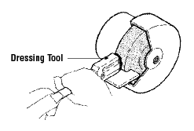
- Dress wheels regularly. Do frequent, light dressings rather than one heavy dressings.
- Support dressing tools so you can apply leverage without undue effort. With revolving cutter dressing tools use the lugs as anchors.
- Replace worn wheels if you cannot dress it.
- Ensure the grinder speed does not exceed the operating speed marked on the wheel.
- Visually inspect wheels for possible damage before mounting.
- Wear proper personal protective equipment:
  - eye, ear and face protection,
  - metatarsal safety boots, where required,
  - respiratory protection may be required, depending on the work.
- Wear gloves only where necessary.
What should you avoid when using bench and pedestal grinders?
- Do not use a wheel that has been dropped.
- Do not use a wheel that does not fit properly to the spindle.
- Do not use excessive force to tighten the nut of the wheel. The force can crack the wheel.
- Do not grind wood, plastics and non-iron metals on ordinary wheels.
- Do not leave grinding wheels standing in liquids. The liquid can cause balance problems.
- Do not grind on the side of a regular wheel.

