Name: _______________________

Drill Press Worksheet

- Before each use, the drill press should be ______________________. During the inspection process, look for:

Part to look at: | Description of what to look for:
Power

Chuck

Drill Bit

Vise

Table

- After using the drill press, it should be ______________________. Brush off the chips from the _____________ and _____________. Do not use ________________ air. Remove the _______________ and place it where it belongs. Sweep the floor around the drill press. Wipe off any excess ________________ or ____________ from the table, vise, and handles.
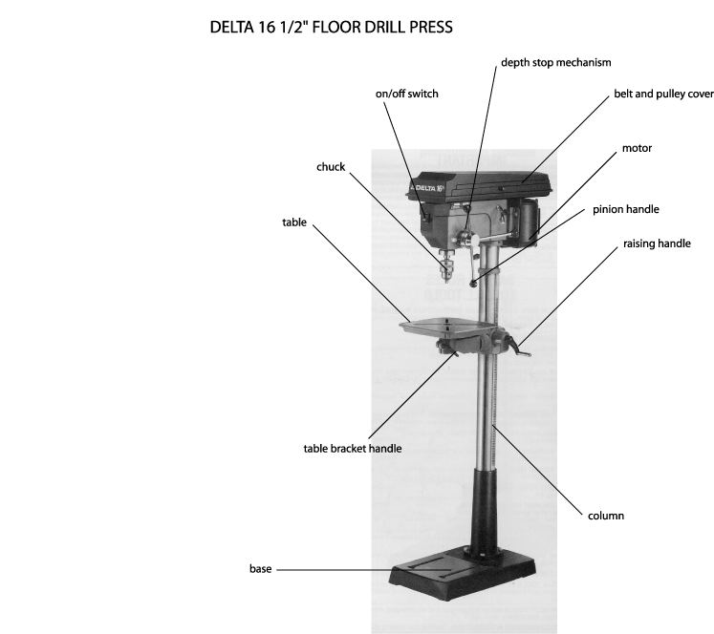
- Label the parts of the drill press below.

