Lathe Part Identification Sheet Name: _____________________ Date:

Part 1: On the following diagram, identify the parts of the wood working lathe.

- Headstock
- Spindle
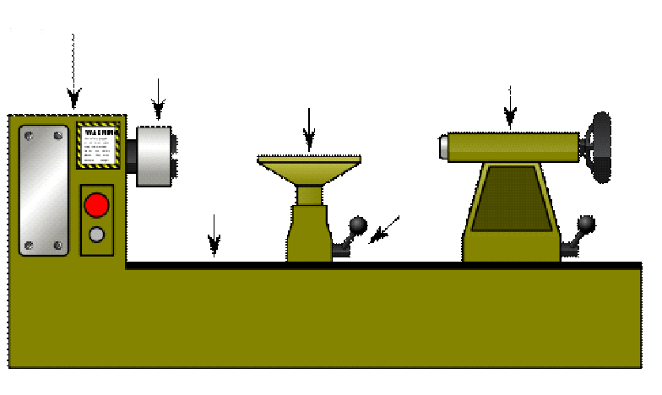
- Tool rest
- Tailstock
- Lock Knob
- Bed

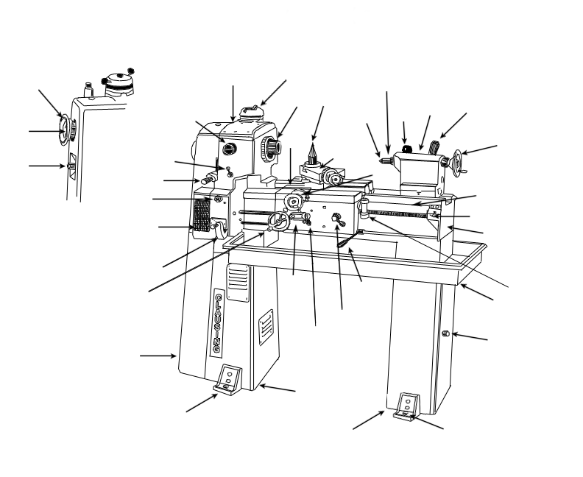
Part 2: On the following diagram, identify the parts of the metal working lathe. Parts list is located on the following page.

- Back gear handwheel
- Back gear pin
- Slide gear handle
- Headstock
- Back gear control knob
- Motor control lever
- Lead screw direction lever
- Selector knob
- Quick-change gearbox
- Thread and feed selector handle
- Carriage handwheel
- Motor and gear train cover
- Foot
- Variable speed control
- Spindle
- Carriage saddle
- Cross-slide Handwheel
- Tool post
- Compound rest
- Tailstock ram

- Dead Center
- Ram lock
- Carriage apron
- Power feed lever
- Headstock pedestal
- Half-nut lever
- Clutch and brake handle
- Tailstock pedestal
- Leveling screw
- Storage compartment door
- Chip pan
- Treading dial
- Bed
- Lead screw
- Rack
- Handwheel
- Tailstock lock lever
- Tailstock

