
Milling Machine Project
- Using a pair of calipers or a micrometer measure your piece of metal down to the thousands of an inch. (length , width)
- Clamp your piece of metal in the mill as instructed by the instructor.
- Using the method that your instructor suggests find the edges of your metal then use this inforfation to find the exact center of your piece of metal.
- Caluclate the speed for the center drill provide by the instructor and center drill you piece of metal.
- Caluclated the speed for the proper drill for tapping 1/2” 13 TPI tap and drill the hole through your piece of metal.
- As instructed by the instructor set- up the milling machine to tap the hole.
- Caluclate the speed for then given countersink. Adjust the micrometer stop on the quill feed to the proper depth for the countersunk screw that your instructor has given you.
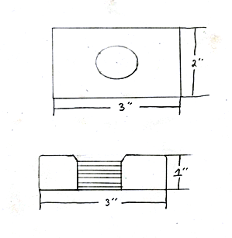
- Deburr your piece with a file and turn your project into your instructor.

