

Architecture, Construction, Communications & Transportation

PATHWAY: Metals Technology
COURSE: Machining Operations II
UNIT 3: ACCT-MOII-3 Job Planning
Annotation:
This unit will teach students the importance of planning ahead and creating a written plan for lathe and milling projects.
Grade(s):
 | 9th
X | 10th
X | 11th
X | 12th

Time:

10 Hours

Author:

Dr. Chesley Chambers

Students with Disabilities:
For students with disabilities, the instructor should refer to the student's IEP to be sure that the accommodations specified are being provided appropriately. Instructors should also familiarize themselves with the provisions of Behavior Intervention Plans that may be part of a student's IEP. Frequent consultation with a student's special education instructor will be beneficial in providing appropriate differentiation. Many students (both with and without disabilities) who struggle with reading may benefit from the use of text reading software or other technological aids to provide access to printed materials. Many of these are available at little or no cost on the internet.
GPS Focus Standards:
ACCT-MOII-3 Students will generate job planning sheets for lathe and milling machine projects.
a. Develop a process plan and sequence of operations for a part requiring turning.
b. Develop a process plan and a sequence of operations for a part requiring milling.
c. Complete a materials list and identify required tools, fixtures, and cutting fluids for a machining operation.

GPS Academic Standards:
MM2P1. Students will solve problems (using the appropriate technology)
a. Build new mathematical knowledge through problem solving.
b. Solve problems that arise in mathematics and in other contexts.
c. Apply and adapt a variety of appropriate strategies to solve problems.
SPS7. The students will relate transformations and flow of energy within a system.
b. Investigate molecular motion as it relates to thermal energy changes in terms of conduction, convection, and radiation.
SPS8. Students will determine relationships among force, mass, and motion.
a. Calculate velocity and acceleration.
c. Calculate amounts of work and mechanical advantage using simple machines

National / Local Standards / Industry / ISTE:
OSHA Guidelines
NIMS Guidelines

Enduring Understandings:
Plan your work and work your plan. This is such a true statement. The better you plan, the better your outcome. Often students want to build something for themselves. With just an idea they begin building, but part way through their building they realize they don’t have all the information and material needed to complete the project. This is very frustrating and discouraging. Most never finish their project. Start with a well thought-out plan and stick to it. There may be some unforeseen changes but overall stick to your plan.

Essential Questions:
• Why is a plan needed for a lathe part?
• What happens when your plan doesn’t work?
• Why is a plan needed for a mill part?
• How do you determine where to start?
• How many steps should a plan have for milling?

Knowledge from this Unit:
Students will be able to:
• Explain the process and steps to produce a lathe part.
• Determine the step by step process for a machined part.
• Describe the process and steps to produce a milled part.
• Discuss the importance of proper machine set up.

Skills from this Unit:
Students will:
• Create a step by step process for a lathe part.
• Formulate a step by step process for a mill part.
• Compile a material and tool list for a machined part.
• Develop a process plan for each operation.

Assessment Method Type:
 | Pre-test
 | Objective assessment - multiple-choice, true- false, etc.
__ Quizzes/Tests
__ Unit test
 | Group project
x | Individual project
 | Self-assessment - May include practice quizzes, games, simulations, checklists, etc.
__ Self-check rubrics
__ Self-check during writing/planning process
__ Journal reflections on concepts, personal experiences and impact on one’s life
__ Reflect on evaluations of work from teachers, business partners, and competition judges
__ Academic prompts
__ Practice quizzes/tests
 | Subjective assessment/Informal observations
__ Essay tests
__ Observe students working with partners
__ Observe students role playing
 | Peer-assessment
__ Peer editing & commentary of products/projects/presentations using rubrics
__ Peer editing and/or critiquing
 | Dialogue and Discussion
__ Student/teacher conferences
__ Partner and small group discussions
__ Whole group discussions
__ Interaction with/feedback from community members/speakers and business partners
 | Constructed Responses
__ Chart good reading/writing/listening/speaking habits
__ Application of skills to real-life situations/scenarios
 | Post-test

Assessment Attachments and / or Directions:
NONE

• LESSON 1: Lathe Turning Process
1. Identify the standards. Standards should be posted in the classroom.
ACCT-MOII-3 Students will generate job planning sheets for lathe and milling machine projects.
a. Develop a process plan and sequence of operations for a part requiring turning.
b. Develop a process plan and a sequence of operations for a part requiring milling.
c. Complete a materials list and identify required tools, fixtures, and cutting fluids for a machining operation.

2. Review Essential Question(s). Post Essential Questions in the classroom.
• Why is a plan needed for a lathe part?
• What happens when your plan doesn’t work?

3. Identify and review the unit vocabulary. Terms may be posted on word wall.
3 jaw chuck | Center drill | Drill chuck
Calipers | Mill vise | Micrometer
Compound rest | Headstock | Tailstock
Tool post | Live center | 4 Jaw Chuck

4. Interest approach – Have a class discussion about what happens when instructions are not followed in sequence. If it is a complex part then it will not turn out correct. Each morning people follow a routine to get their day going. Get out of bed, brush teeth, get dressed, eat breakfast, drive or ride bus to school or work, do your job, eat lunch. Now imagine if these steps were mixed up and not followed in order. Some may not make a difference but if you forgot to get dress before going to school then it would be embarrassing.
Point out that the key is to take one step at a time. Often a complex part is overwhelming but when it is broken down into small steps it is easier to understand.

5. Develop a step by step process for the following drawing. Put in diameters and lengths. Show students the Lathe Turning Presentation to show them the step-by-step process.
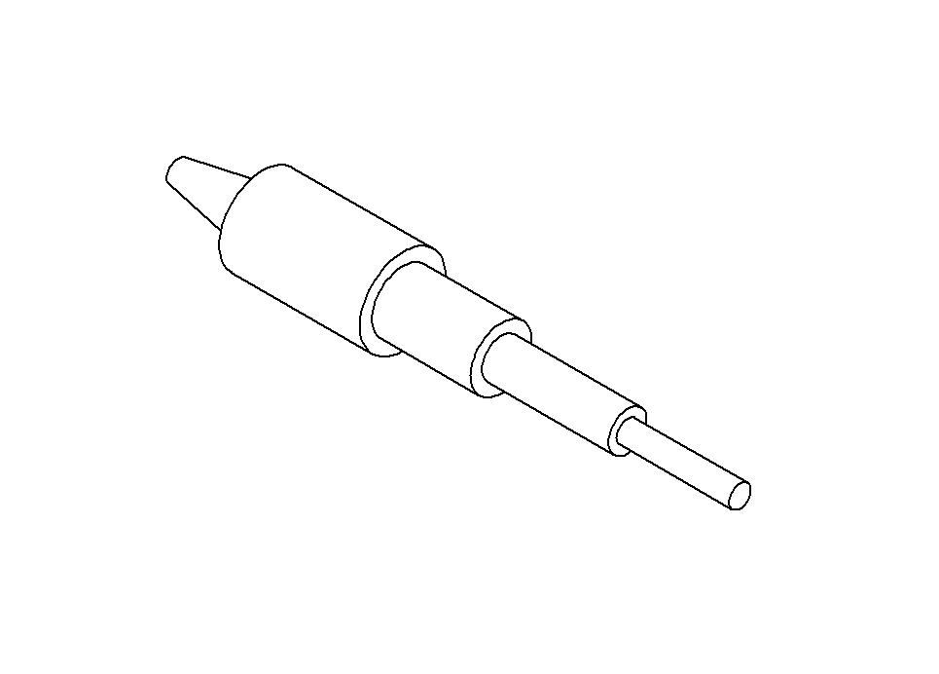
6. Have the students sketch each process from the beginning raw stock until the finished part. They should start with the largest diameter first and work their way down.

7. Summary: Following proper sequence is important in producing a good part. It takes less time to do it once than to redo it a second time. This is planning so the first draft most likely will not be the finished draft.

• LESSON 2: Milling Process
1. Review Essential Questions. Post Essential Questions in the classroom.
• Why is a plan needed for a mill part?
• How do you determine where to start?

2. As a class, discuss the following statement: Where you start will determine where you finish, or does it? For a machined part it determines how you finish. Proper machine set up and calibration is crucial to producing a good part. The vise must be true and the machine head must be trimmed in. You could skip a lot of time just to finish with a part that is not square.

3. Develop a step by step process for the following drawing. Put in dimensions for the part. The first step is to square up the part. Show the class the Milling PowerPoint to complete the rest of the steps.
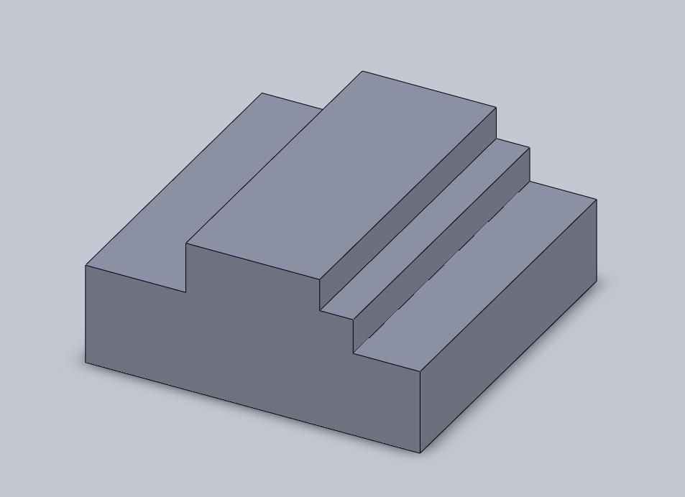

4. Have the students sketch out each step of the process. Take one plane at a time.

5. Summary: Breaking a part down into step by step operations simplifies the complex part. Remember that if the first step is not machined within tolerance then it will affect the other steps.

• LESSON 3: Material List for turning and milling.
1. Review Essential Questions. Post Essential Questions in the classroom.
• How do you determine where to start?
• What happens when a measuring tool is not calibrated?

2. Have a group discussion on how having the proper tools to do a job will determine the amount of time it takes to complete the job and the quality of the job. The part is only as accurate as the tools used to measure it.

3. Using the Material List PowerPoint, review the various measuring tools needed for a lathe part and the parts to a lathe and fixtures needed. Also, review the various measuring tools needed for a mill part as well as the parts to a milling machine and vised needed to produce a part.

4. Have the students practice identifying the measuring tools and fixtures needed to produce a part on the lathe and milling machine

5. Summary: The part is only as accurate and the tools used to measure it. The machine must be properly set up to produce an accurate part.

• ATTACHMENTS FOR LESSON PLANS
• Lathe Turning Presentation
• Milling PowerPoint
• Material List PowerPoint

• NOTES & REFLECTION:
Having the students sketch the each step of the process will help them understand how each one should be machined. Try to get them to take it one step at a time. Looking at the finished part sometime is overwhelming.

Culminating Unit Performance Task Title:
Lathe Turning and Milling

Culminating Unit Performance Task Description/Directions/Differentiated Instruction:
Have students use their sketches and plans as a guide for hands on time lathe turning and milling. Grade them using the Lathe Turning and Milling Checklist.

Attachments for Culminating Performance Task:
• Lathe Turning and Milling Checklist Handout

Web Resources:
• www.MSCdirect.com (for a list of tools and fixtures)
- www.NIMS.org
- www.OSHA.org

Materials & Equipment:
- Computer with Internet Access
- Projection Equipment
- Block at least 2.600” x 2.600” x 1.250”
- 0-1 Micrometer
- 1-2 micrometer
- Calipers
- Square
- Mill vise
- Vise parallels
- Dial indicator
- End mill cutter
- Round stock 1 1/5” diameter 10” length
- File
- Calipers
- Scale
- Turning tool
- Center drill

Suggested Testbooks:
- Machining Fundamentals. Copyright 2004. John R. Walker. The Goodheart-Willcox Company, INC. ISBN 1-59070-249-2
- Machining Fundamentals Workbook. Copyright 2004. John R. Walker. The Goodheart-Willcox Company, INC. ISBN 1-59070-250-6
- Modern Metalworking. Copyright 2004. John R. Walker. The Goodheart-Willcox Company, INC. ISBN 1-59070-224-7
- Modern Metalworking Workbook. Copyright 2004. John R. Walker. The Goodheart-Willcox Company, INC. ISBN 1-59070-225-5

21st Century Technology Used:

X | Slide Show Software |  | Graphing Software |  | Audio File(s)
 | Interactive Whiteboard | X | Calculator |  | Graphic Organizer
 | Student Response System |  | Desktop Publishing |  | Image File(s)
 | Web Design Software |  | Blog |  | Video
 | Animation Software |  | Wiki |  | Electronic Game or Puzzle Maker
 | Email |  | Website

