Post Test
Answer the following questions on the line to the right. (2 pts each)
- What is the formula used to find the circumference of a circle? __________
- What other way can this formula be written? __________
- What is the Pythagorean Theorem? __________
- We can use the Pythagorean Theorem when
one angle of a triangle measures how many degrees? __________
Solve the following problems. Show your work in the margins. (3 pts each)
- (1/4) x (7/12) = 3. (1 ½) x (7/8) =
- 7/12 = 4. 11/16 =
5/8 1/8
Measure the following lines using the 8th inch scale. Write your answers on each line.
- 3.

Measure the following lines using the 16th inch scale.
- 4.

For each problem, show your work and include a diagram. Circle the final answer. (up to 10 points each)
- A Right Triangle has a hypotenuse of an unknown length. The other sides measure 72 cm and 54 cm. What is the length of the hypotenuse?

- The longest side of a Right Triangle measures 20 in. The shortest side measures 12 in. What is the length of the remaining side?

- A circle has a radius of 5/16 in. What is the circumference of this circle?

- A circle has a diameter that is 5 inches longer than its radius. What is the circumference of this circle?

- Use the Pythagorean Theorem to find the length of side G. Show your work to the right. 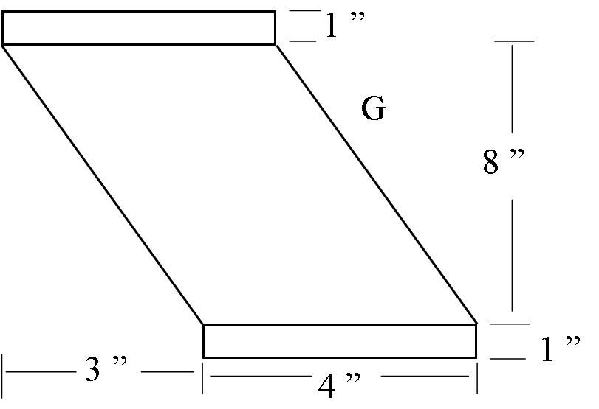

- Use the Pythagorean Theorem to find the length of side H. Show your work to the right.
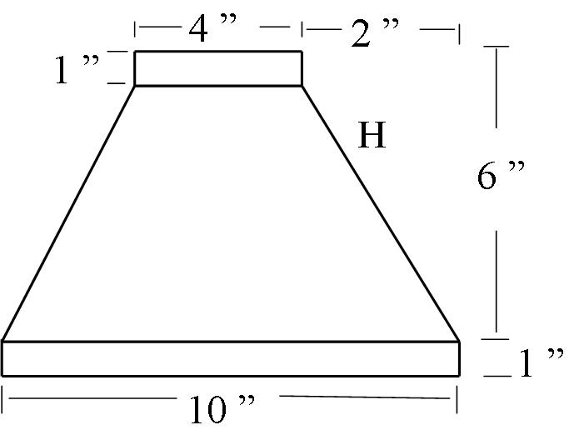

- Find the stretch out for a piece of duct work that is 6 ‘ long with a diameter of 12 ”.

- Find the circumference for a collar with the diameter of 6 “

Bonus: In the following diagram, combine what you know of the Pythagorean Theorem with what you have learned about Circumference to find the circumference of the circle (Hint: The Hypotenuse of the triangle goes through the middle of the circle.)
15 cm
20 cm

