Post Test
Answer the following questions on the line to the right. (2 pts each)
- What is the formula used to find the circumference of a circle? C = 2πr___
- What other way can this formula be written? C = πd___
- What is the Pythagorean Theorem? a² + b² = c²_
- We can use the Pythagorean Theorem when
one angle of a triangle measures how many degrees? ____90°___
Solve the following problems. Show your work in the margins. (3 pts each)
- (1/4) x (7/12) = 7/48 3. (1 ½) x (7/8) = 21/16
- 7/12 = 14/15 4. 11/16 = 11/2 =5 ½
5/8 1/8
Measure the following lines using the 8th inch scale. Write your answers on each line.
- 3.

Measure the following lines using the 16th inch scale.
- 4.
Instructor should measure these once printed to ensure consistency.

For each problem, show your work and include a diagram. Circle the final answer. (up to 10 points each)
- A Right Triangle has a hypotenuse of an unknown length. The other sides measure 72 cm and 54 cm. What is the length of the hypotenuse?
(72)² + (54)² = c²
5184 + 2916 = c²
8100 = c²
c = 90 cm
- The longest side of a Right Triangle measures 20 in. The shortest side measures 12 in. What is the length of the remaining side?
c² = a² + b²
(20)² = (12)² + b²
400 = 144 + b²
b² = 256
b = 16 in.

- A circle has a radius of 5/16 in. What is the circumference of this circle?
c = 2πr
c = 2(3.14)(5/16)
c = 1.96 in.

- A circle has a diameter that is 5 inches longer than its radius. What is the circumference of this circle?
d = r + r c = 2πr
d=r+5 c=2(3.14)(5)
r+5=r+r c=31.4 in.
r=5

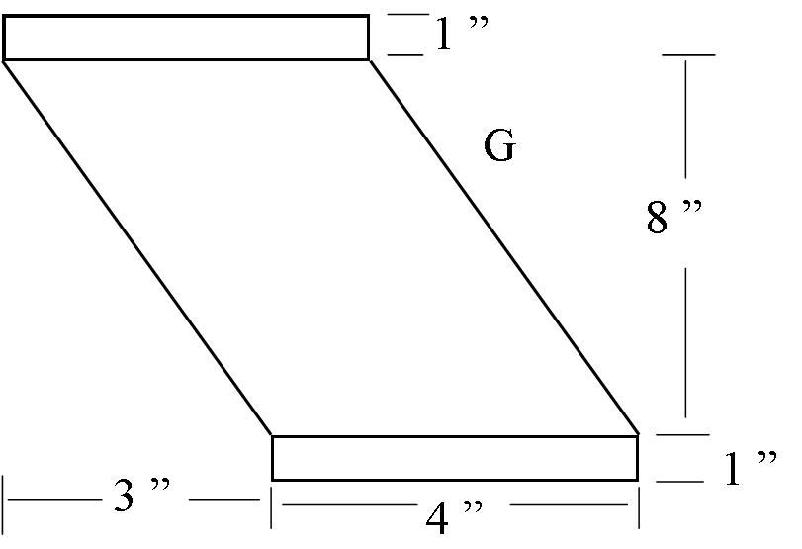
- Use the Pythagorean Theorem to find the length of side G. Show your work to the right.
a² + b² = c²
3² + 8² = c²
9 + 64 = c²
73 = c²
c = 8.54 ”
Side G measures 8.54 ”

- Use the Pythagorean Theorem to find the length of side H. Show your work to the right.
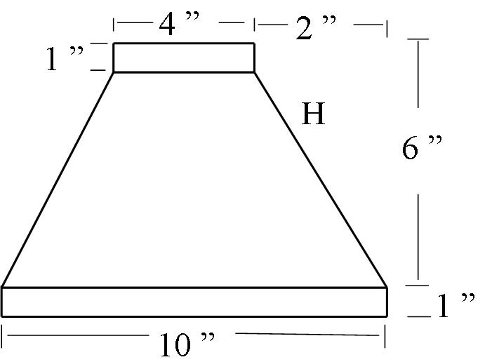
a=2 b=6-1=5 c=H
2² + 5² = c²
4 + 25 = c²
29 =c²
c= 5.39 ”

- Find the stretch out for a piece of duct work that is 6 ‘ long with a diameter of 12 ”.
Pay attention to units.
C = πd or C= πd
C = (3.14)(12”) C = (3.14)(1 ’ )
C = 37.68 “ = 3.14 ’ C = 3.14 ’
The stretch out will be 6 ’ by 3.14 ’

- Find the circumference for a collar with the diameter of 6 “
C = πd
C = (3.14)(6 ”)
C = 18.84 ”

Bonus: In the following diagram, combine what you know of the Pythagorean Theorem with what you have learned about Circumference to find the circumference of the circle (Hint: The Hypotenuse of the triangle goes through the middle of the circle.)
15 cm
20 cm
C = πd
d = c
a² + b² = c²
15² + 20² = c²
225 + 400 = c²
625 = c²
c = 25 cm = d
C = πd
C = (3.14)(25)
C = 78.5 cm

