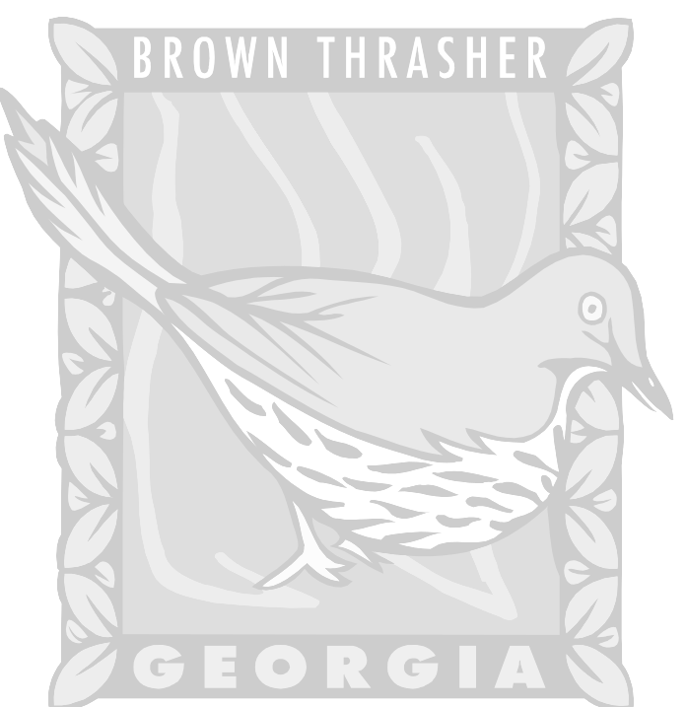  Georgia:  State Bird: Brown Thrasher  State Flower: Cherokee Rose  State Vegetable: Vidalia Onion  State Tree: Live Oak- The 1st colonists tried to grow oranges under Live Oak Trees.  State Reptile:Gopher Tortoise (lives in holes in the ground)  State Insect:Honey Bee (pollinates over 50 crops)  Largest & Strongest Agricultural Organization: Georgia Farm Bureau Federation | Agricultural Universities:  - Fort Valley State University- Albany, Ga- Small Ruminant Research (goats)  - University of Georgia- 1st Southern School of Forestry  
Crops  *Georgia- 1st colony to produce cotton commercially.  *Although Georgia is called the Peach State, it actually ranks 3rd in the US peach production behind California and South Carolina.  *Wolf peaches is another name for tomatoes.  *Today’s horticultural industry employs more than 40,000 Georgians. Horticultural crops are established in landscapes. Most of Georgia’s horticulture industry is from nursery plants.  *Georgia also raises Christmas trees (mostly Leyland Cypress).  *One of Georgia’s top vegetables is sweet corn.  *A byproduct of corn is used as an absorbent in baby diapers.  *The ear of the corn is female.  * Nubbin- small stunted ear of corn.  *Albany is the Pecan Capital of Georgia. | Animals:  *Georgia farmers raise beef cattle.  *Fat in cattle is called marbling.  * A cow magnet is placed in the stomach of a cow to collect metal objects swallowed by cows.  * Cattle guards are grids set at ground level at  a gateway to prevent livestock from crossing.  *Cattle get up on their back legs first.  * Cattle have 4 stomachs (ruminant).  *Georgia farmers raise dairy cattle.  *A Georgia dairy cow produces 6.6 gallons of milk per day.  * Georgia farmers raise swine (pigs).  * A shoat is a young hog just after weaning.  * A byproduct of pig skin is Jello.  * Georgia farmers raise horses.  * A farrier shoes horses.  * Georgia farmers raise poultry.  * Gainesville is the Poultry Capital of the World.
General:  *15-20% of Georgians work in agriculture, forestry or a related sector.  *Agriculture is Georgia’s largest industry. | Expressions:  *Fair to middling- grade of cotton  *Short rows- near the end of a long task.  *Good Friday- Best day to plant spring garden
Inventions:  * Velcro was inspired by the cocklebur weed.  * Gregor Mendel paved the way for improving crops through genetics.  *George Washington Carver- 325 uses for peanuts.  * Stringing Horse: once used in tobacco harvesting (not an animal)  *Hoecake: bread baked on a hoe over a fire.  *Sugar- comes from sugar cane and sugar beets | Forestry:  *More than 65% (2/3) of Georgia is in forestland.  * Tools used in Forestry:  *Increment Borer  * Biltmore Stick: measures standing trees  * Fat Lightered- wood used for starting fires.

