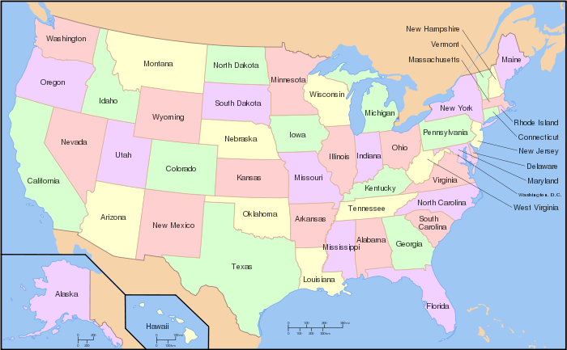
Beef
Chicken
Dairy
Eggs
Pork
Soybeans
Tomatoes
Wheat

Legend
O Beef: Texas, Nebraska, Kansas, Colorado, Iowa, Oklahoma, and California.
O Chickens: Arkansas, Georgia, Alabama, North Carolina, Mississippi, and Texas.
O Dairy Products: Wisconsin, California, New York, Pennsylvania, Minnesota, and New England.
O Eggs: California, Georgia, Arkansas, Indiana, Pennsylvania, and Texas.
O Pork: Iowa, Illinois, Minnesota, Nebraska, Indiana, North Carolina, and Missouri.
O Soybeans, major oil crop used in salad dressings and mayonnaise: Illinois, Iowa, Nebraska,
Indiana, Minnesota, and Ohio.
O Tomatoes: Florida, California, Virginia, Ohio, Georgia, and Michigan.
O Wheat: North Carolina, Kansas, Montana, Oklahoma, Washington, and Minnesota

