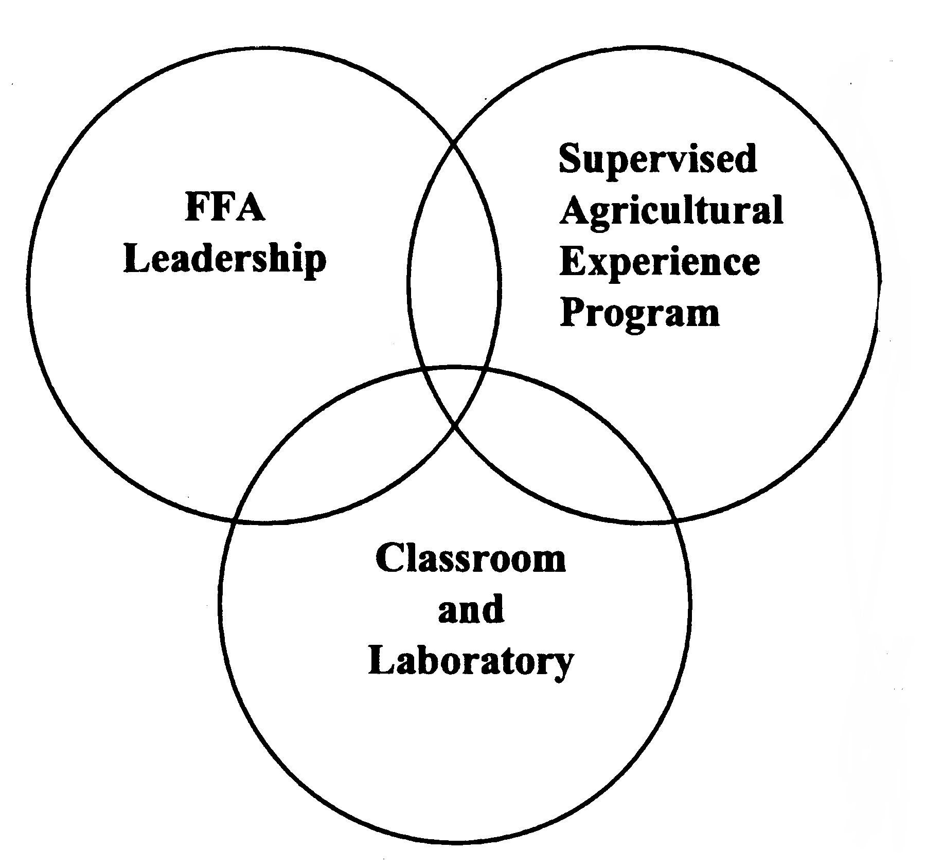
Clubs & Activities
Future Career Interests
Favorite Subjects in School

