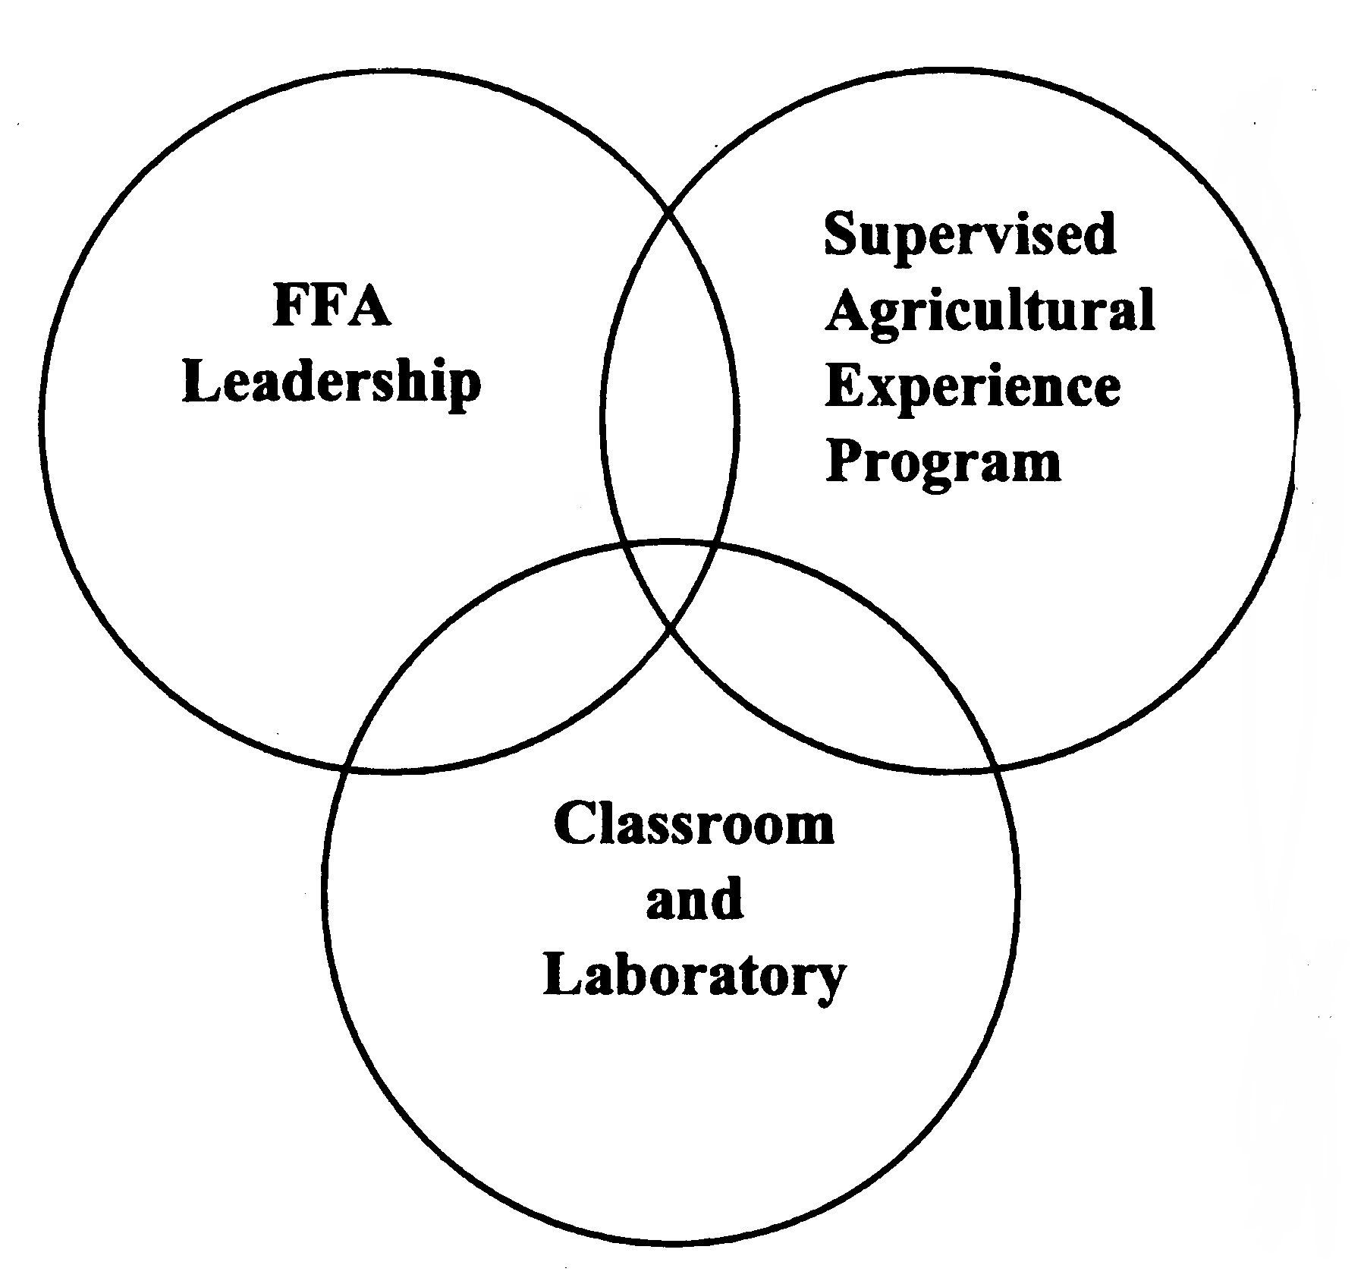
Word Bank

Career Development Event (CDE) Livestock Exhibit Textbooks
Entrepreneurship Greenhouse Placement
Discovery Degree Banquet FFA Quiz
FFA Creed Worksheets Research
Travel State Convention Official Dress
Motto Microscopes Job Shadow
Build Birdhouse Growing Tomatoes Pet Care

