THE AGRICULTURE CYCLE
AGRICULTURE JOBS ARE EVERYWHERE!
The Agriculture Cycle employs millions of people in many different kinds of jobs. Follow the cycle below. At each step list TWO jobs taken from the word bank below.

Production – growing and harvesting Processing – changing food and
food, fiber, forests, and flowers fiber products into things we can use
Harvesting wheat from a field Making potato chips in a factory
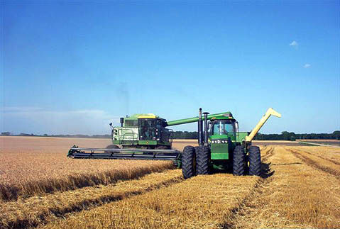
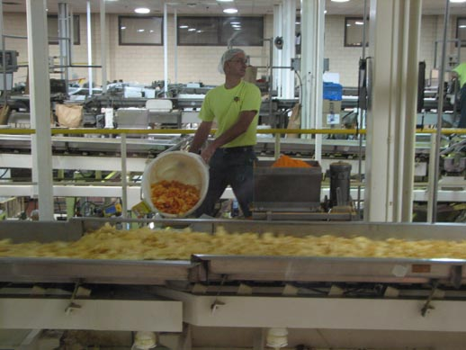

Production Jobs Processing Jobs
- _______________________ 1. _______________________
- _______________________ 2. _______________________

Marketing – selling food and finished Transportation – moving crops and
products to you! food products around the world
Shelves with bakery good for sale Loading pallets for shipping
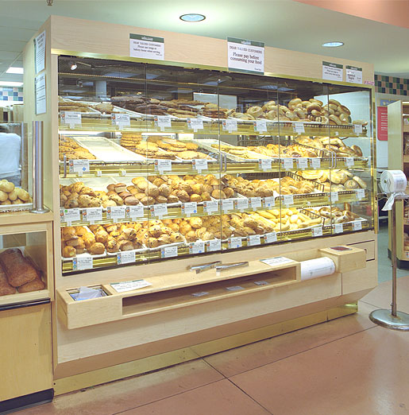
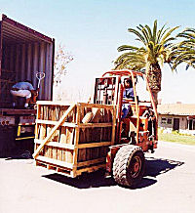

Marketing Jobs Transportation Jobs
- _______________________ 1. _______________________
- _______________________ 2. _______________________

Agriculture Job Bank

Baker | Bale Loader | Logging Engineer
Cashier | Horticulturist | Fork Lift Driver
Mechanic | Accountant | Refrigeration Mechanic
Chef | Longshoreman | Advertising Executive
Butcher | Food Chemist | Computer Technician
Forester | Tractor Driver | Irrigation Specialist
Electrician | Agronomist | Product Manager

