Common Fall Leaves

  1. ______________ | 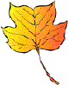  2.______________ |   3._______________ |   4.________________
 5. ___________ |   6.______________ | 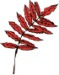  7._______________ |   8.________________
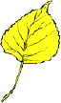9.____________ | 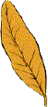  10________________ |   11________________ | 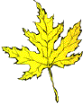  12___________
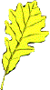  13_____________ | 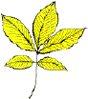  14_______________ | 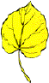  15______________ |   16_______________
 |   17__________ | 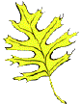  18___________

