 | Use the key to unlock the message. The answer is hidden somewhere on the page.
Enemies  of the Forest  Letter Key  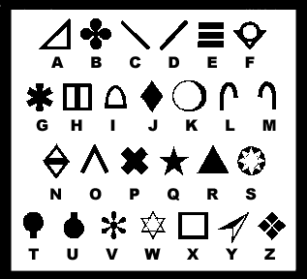  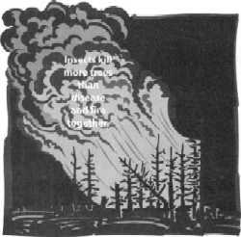 | 