Enemies of the Forest Answer Key
INSECTS = 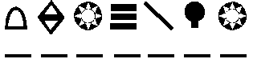
KILL = 
MORE = 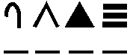
TREES = 
THAN = 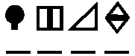
DISEASE = 
AND = 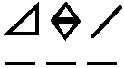
FIRE = 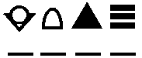
TOGETHER = 