Forest Families:  Directions & Rules | Read the information and questions below then write your answers on the back of this sheet.
Objectives:  To collect Forest Families sets. The player with the most number of sets is the winner.  Rules:  1. The dealer shuffles the cards then passes them all out, face down, to all the players (If playing with 3 or 5, see the suggestions for alternate play.)  2. Players organize their hand in sets made from the Forest Families that they were dealt.  3. The player to the right of the dealer begins the play. This "lead" player chooses a "target" player to question in order to collect more cards to add to the partial sets he already has in his hand.  4. The first question on every player's turn is always to find out whether the target player has cards in a particular forest family that the lead player wishes to collect.  Example: "Tommy, do you have Parts of a Tree family?" If Tommy doesn't have one of the cards in that set, he answers "No." The first player then loses his turn.  5. If Tommy does have one or more in the chosen category, he answers the lead player, "Yes, I do." He should not tell which card or cards he has. The lead player then can ask a question about a particular member of that family.  Example: "Tommy, do you have the Sapwood? If Tommy doesn't have that particular card, the first player loses his | turn. If Tommy has that card, he must hand over the card, and the first player gets to continue with his turn. He can now ask Tommy or another player about a forest family of his choice. The forest family may be a different one, or it may be in the same family he was collecting before.  6. Players take turns asking questions as they try to collect all the cards in a particular family until all the cards in the deck are collected in sets by the different players in that group.  7. Additional information about members of Forest Families are on each card to allow players to review and add to what they have learned in the previous lessons.  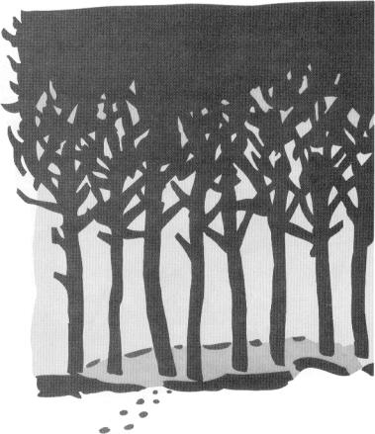

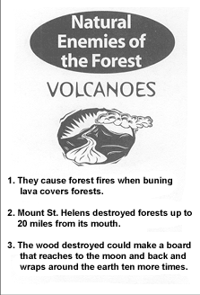 | 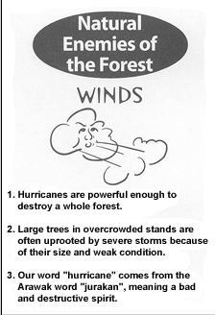 | 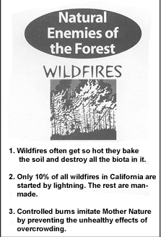
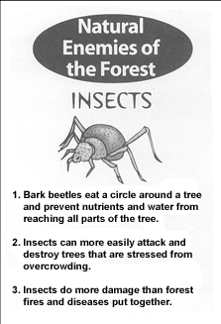 | 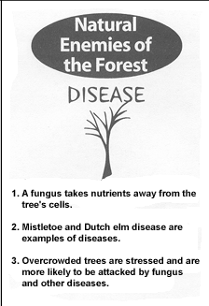 | 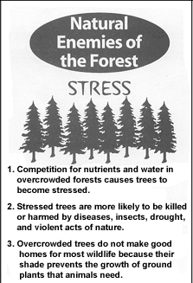

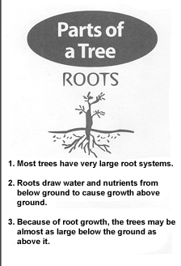 | 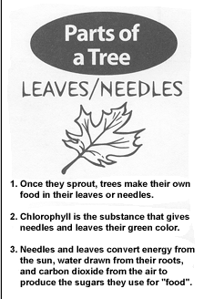 | 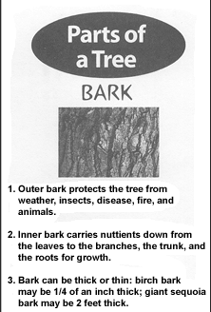
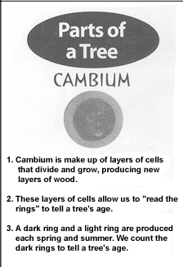 | 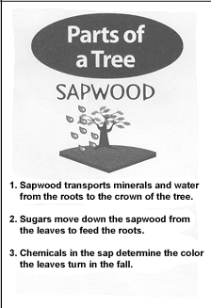 | 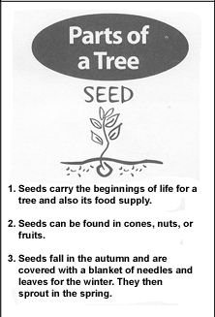

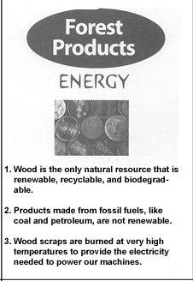 | 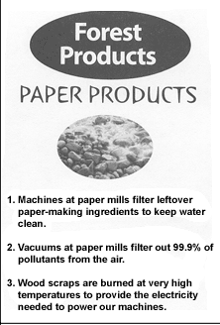 | 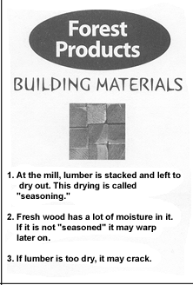
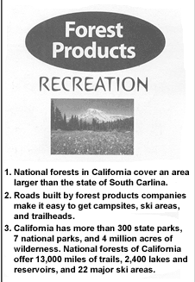 | 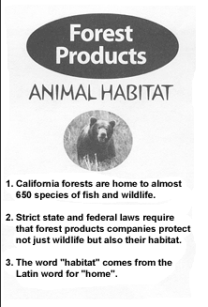 | 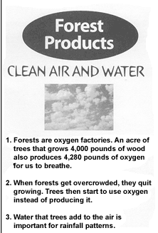

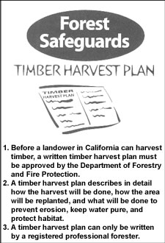 |  | 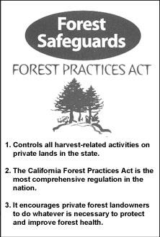
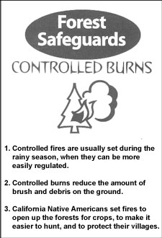 | 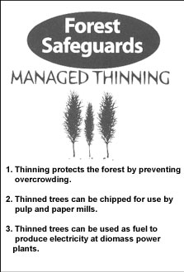 | 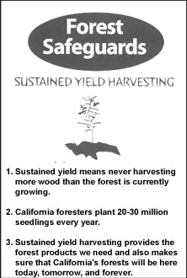

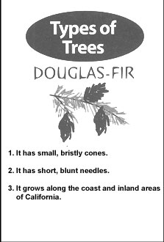 | 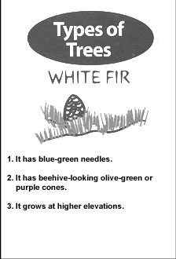 | 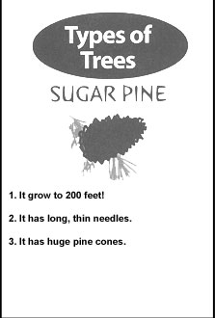
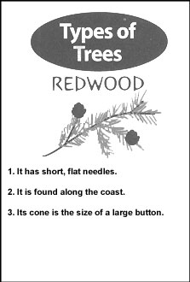 | 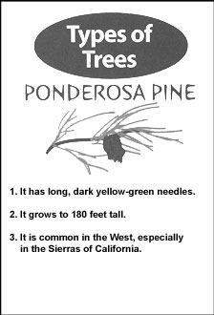 | 