PICK A LEAF

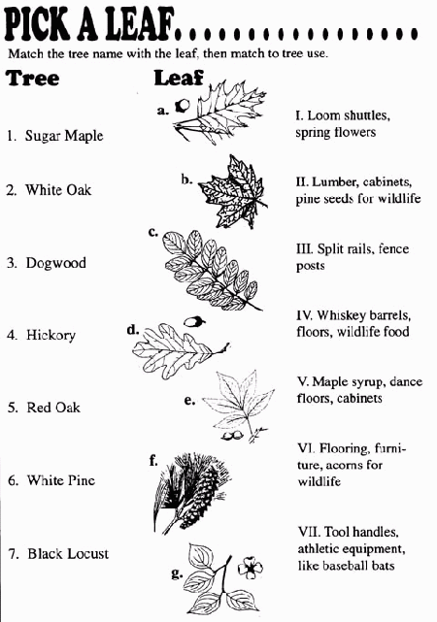

Answers:1-b-V, 2-d-IV, 3-g-I, 4-e-VII, 5-a-VI, 6-f-II, 7-c-III

