The Compass Activity Page
Look at the picture of the baseplate or orienteering compass. Study the names of the parts. Then, choose True or False to answer questions on the Compass Quiz.
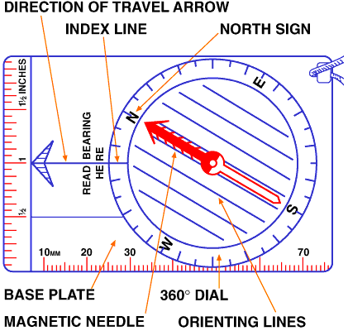

The Compass Quiz
1. | A compass needle is magnetized.
  True | False
2. | The red part of the compass needle points to Earth's magnetic South Pole.
  True | False
3. | A compass works best when held flat.
  True | False
4. | Since a compass is affected by magnetic fields, it needs to be used away from iron and steel objects.
  True | False
5. | The compass housing cannot be turned or rotated.
  True | False
6. | The scale of the compass is 0 to 360 degrees.
  True | False
7. | The cardinal direction points N, S, E and W correspond to degrees. North is 0 or 360. South is 180. East is 90. West is 270.
  True | False
8. | Orienting lines help to line up the compass with a globe.
  True | False
9. | The compass needle is painted two colors (Red - North, White - South.)
  True | False
10. | Good compasses have fluid filled housing that allows the needle to move slowly.
  True | False
11. | The parallel lines inside the dial are known as orienting lines.
  True | False

Answers:

- True
- False
- True
- True
- False
- True
- True
- False
- True
- True
- True

