. | Tools of the Trade Forestry Quiz  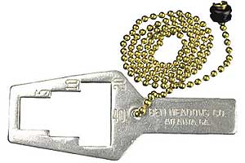  1. What is this angle gauge used for?  This tool is used by foresters for:  - opening bottles  b) measuring bark thickness  c) measuring how crowded trees are in the forest  d) checking the tread on their truck tires
  . | 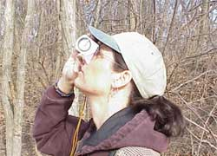  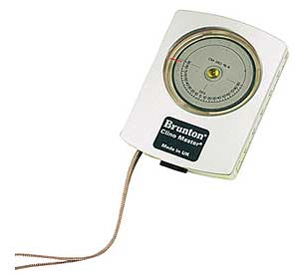  What is this clinometer used for?  ©Photo courtesy of Ben Meadows Company, Janesville, WI  2. This tool is used by foresters to:  a) measure the height of a tree  b) measure the rate of sap flow  c) tell what direction they are walking  d) measure the windspeed
    . | 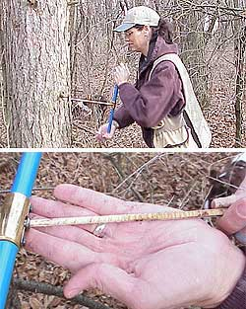  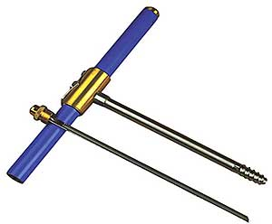  What is this increment borer used for?  ©Photo courtesy of Ben Meadows Company, Janesville, WI  3.This tool is used by foresters to:  a) take a tree’s temperature  b) tell how old a tree is  c) drill a tap hole for collecting maple sap  d) collect soil samples  Here you can see Mary Ann drilling the  increment borer into a red pine. Next  the wood core is removed using the extractor.
      4. Tools of the Trade Forestry Quiz
      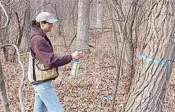
      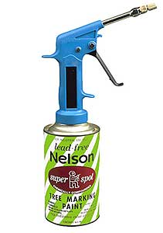
      What is this paint gun used for?
      ©Photo courtesy of Ben Meadows Company, Janesville, WI
      This tool is used by foresters to:
      a) mark buried power lines
      b) spray our motto “trees rule!” on railroad cars
      c) stun wild animals that may attack us in the forest
      d) mark trees designated for harvest

