Plumbing Activity - Bill of Materials

Name: ______________________ Date: ____________________
45
90
Male Adaptor
Spigot
11 ½”

8”
11”
45
Thread Tee

14”
10 ½”
Slip Tee

16”
4”
90

Pipe | _____ft | x | $2.30 per 10’ stick | = | _________
90º Elbow | #used_____ | x | $0.30 each | = | _________
45º Elbow | #used_____ | x | $0.30 each | = | _________
Threaded Tee | #used_____ | x | $0.79 each | = | _________
Slip Tee | #used_____ | x | $0.60 each | = | _________
Spigot | #used_____ | x | $3.39 each | = | _________
 |  |  | Subtotal | = | _________
Labor | $_75_per hour | x | 45 minutes | = | _________
 |  |  | Total | = | _________

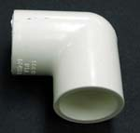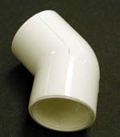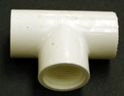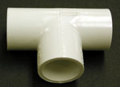
90º Elbow 45º Elbow Threaded Tee Slip Tee

Pipe can be calculated by adding all the inches together then dividing by 12 in order to have the length in feet, since 12 inches = 1 foot.
Answer Key

Pipe | 6.25 ft | x | $2.30 per 10’ stick | = | 2.30
90º Elbow | #used_____ | x | $0.30 each | = | .60
45º Elbow | #used_____ | x | $0.30 each | = | .60
Threaded Tee | #used_____ | x | $0.79 each | = | .79
Slip Tee | #used_____ | x | $0.60 each | = | .60
Spigot | #used_____ | x | $3.39 each | = | 3.39
 |  |  | Subtotal | = | $8.28
Labor | $_75 per hour | x | 45 minutes | = | 56.25
 |  |  | Total | = | $64.53

