Importance of Agriculture Mechanics Test

The Nuts and Bolts of Agriculture

Answer the question with the best answer (4 points)

- What is the importance of ag mechanics?
_______________________________________________________________
- Some uses of plumbing are _____________________________________ and _____________________________________.
- The tool used to cut PVC pipe is called a _________________________.
  - Hacksaw c. Miter Box
  - Mitersaw d. Drill
- Some careers associated with Ag Mechanics are ___________________________ and ______________________________.
- Today less than _______ % of Americans are farmers
  - 2 c. 10
  - 5 d. 25
- The cotton gin was invented by ____________________________________.
  - Cyrus McCormick c. Eli Whitney
  - John Deere d. Anna Baldwin
- Copper pipe is used for __________________________________________.
  - Hot water only c. Outdoor water lines
  - Cold water only d. Both hot and cold water

- The tractor was invented by ____________________________________.
  - Edmund Quincey c. John Deere
  - Benjamin Holt d. Eli Whitney
- The type of pipe used in large sewage systems is ________________________.
  - Cast Iron c. PVC
  - Copper d. Concrete
- Why is lab safety an important part of agriculture mechanics?
__________________________________________________________________
- Teflon Tape is used to ________________________________________.
  - Prevent leaks c. Cut the pipe
  - Glue pipes together d. Clean the pipe
- Cyrus McCormick invented the ____________________________.
  - Steele Plow c. Reaper
  - Tractor d. Grain Elevator
- ____________pipe is covered in zinc.
  - Black Steel c. Polyethylene
  - PVC d. Galvanized Steel
- Two rules that should be followed while working in the lab are
  - __________________________________________________________
  - __________________________________________________________
- To smooth the ends of the pipe, you should use __________________________.
  - Cloth c. Zinc
  - Sandpaper d. Cement Solvent
- The type of pipe that is used to replace regular PVC and Copper is ___________.
  - Black Steel c. Polyethylene
  - PVC d. Galvanized Steel
- The purpose of covering a pipe in zinc is to ____________.
  - Prevent leaks c. Fuse pipes together
  - Prevent cracks d. Prevent Rust
- 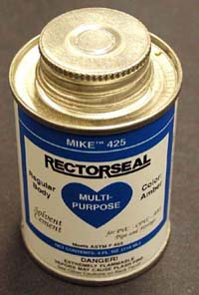 This is _________________________________________.
  - Hacksaw c. Pipe Cement Solvent
  - Teflon Tape d. Elbow
- Number 14 is used to ____________________________________________.
- 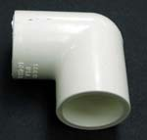 This is a __________________________________________.
  - 90 Square Elbow c. 45 Square Elbow
  - 90 Slip Elbow d. 45 Slip Elbow
- 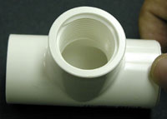 This is a _________________________.
  - Slip Elbow c. Slip Tee
  - Threaded Elbow d. Threaded Tee
- 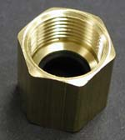 This is a ___________________________________________.
  - Bass Connector c. Square Elbow
  - Male Adaptor d. Threaded Tee
- 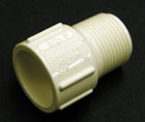 This is a ______________________________________.
  - Bass Connector c. Square Elbow
  - Male Adaptor d. Threaded Tee
- Briefly explain what life might have been like before plumbing was invented.

- What do you think you will gain by completing this plumbing project?

