PVC Plumbing Project

45
90
Male Adaptor
Spigot
11 ½”

8”
11”
45
Thread Tee

14”
10 ½”
Slip Tee

16”
4”
90

Instructions: Make this configuration by following the directions below out of PVC pipe using the different fittings you learned.

How to assemble the PVC pipe:
- Cut the pipe the lengths needed to construct the configuration shown above.
- Clean the end of the pipe of ragged edges using sand paper.
- Also clean the inside of the fitting to remove any dirt or grease.
- Apply the pipe solvent around the end of the pipe and also the inside of the fitting.
- Push the fitting and the pipe together. Twist the pipe to distribute the solvent evenly in the joint.
- Keep pressure on the pipe and fitting for at least 30 seconds to prevent the pipe from backing out of the fitting.
- Repeat until all fitting have been attached
- Remove the excess glue with a clean rag.
- Let the glue cure for at least 15 minutes before handling.
- To attach spigot apply Teflon tape around the male end of the spigot.
- Twist the spigot into the Threaded Tee for a tight fit.

To Test: Under teacher supervision, take finished plumbing project outside and hook up to the water hose to see if it leaks.
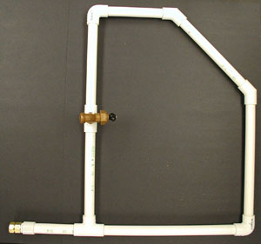

Bill of Materials

Name: ______________________ Date: ____________________

Company Name ________________________________

Pipe Used _________ Ft x $____ per foot = ____________

90 Elbow # used ________ x $_____ each = ____________

45 Elbow # used ________ x $_____ each = ____________

Slip Tee # used ________ x $_____ each = ____________

Threaded Tee # used ________ x $_____ each = ____________

Spigot # used ________ x $ _____each = ____________

Adaptor # used ________ x $_____ each = ____________

Teflon Tape # used ________ x $_____ each = ____________

Glue # used ________ x $_____ each = ____________

Subtotal = _____________

Labor $_____ per hour x ______ hours = _____________

Total = _____________

Pipe can be calculated by added all the inches together (4, 8, 10 ½, 11, 11 ½, 14, & 16)
Divide by 12 (there are 12 inches in 1 foot)
Round up to the nearest whole number

