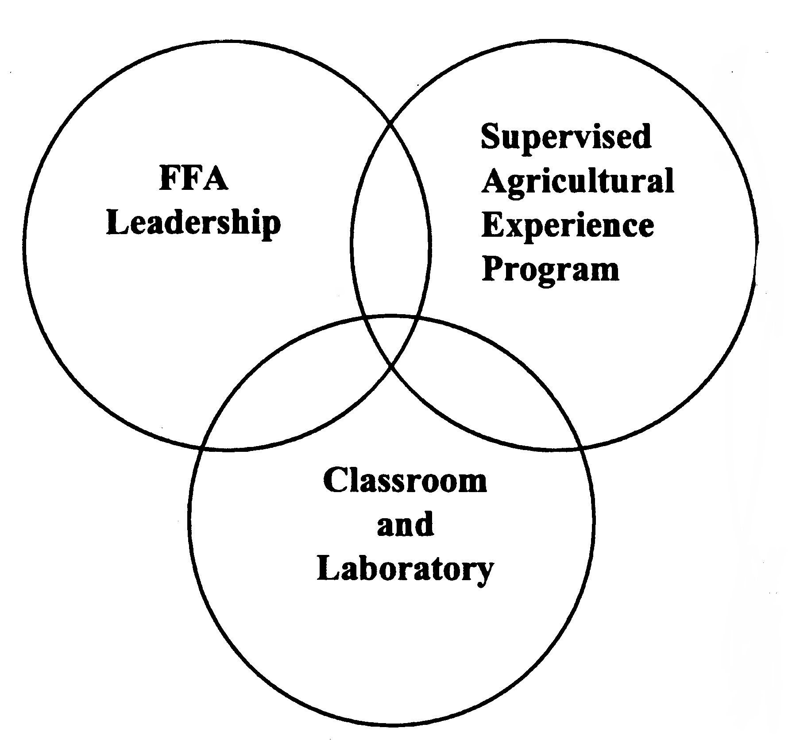
3 Parts of the Agricultural Education Program

