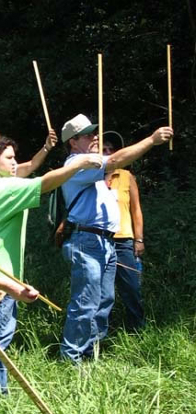
Parallel and Perpendicular Lines
How do they help you use a Biltmore Stick in forestry?
Meets Mathematics Georgia Performance Standards: M8G1, M8P4
Name: ______________________ Date: ________

Instructions: After you have learned how to use a Biltmore Stick to measure trees, complete the following questions regarding parallelism and perpendicularity.

1. Explain, in your own words, what it means for two lines to be parallel.

2. Explain, in your own words, what it means for two lines to be perpendicular.

3. When using a Biltmore stick to measure the height of a tree, it is important to hold the Biltmore stick _____________ to the tree.

4. Using your answer to question 3, why is this important?

5. When using a Biltmore stick to measure the diameter of a tree, it is important to hold the stick __________ to the tree.

6. Using your answer to question 5, why is this important?

7. Since trees grow fairly straight up, they grow _____________ to the ground.

8. When you stand straight up, you are ______________ to the ground.

9. In terms of vertical and horizontal lines, how would you describe the ground?

10. Using your answers from questions 7 and 8, how would your relate yourself to a tree in terms of parallelism and perpendicularity?

11. Using your description from question 7, how would you relate yourself (standing straight up) to the ground in terms of parallelism and perpendicularity?

12. Identify the following line segments below as parallel ( // ), perpendicular ( ┴ ), neither (N), or both (B).

a. b. c. d. e.

a.__________ b.__________ c. __________ d.__________ e.__________
1. For two lines to never intersect.

2. For two lines to intersect at right angles to one another.

3. Parallel

4. If you do not hold the stick parallel you will have a parallax, defined as an apparent displacement or difference in the apparent position of an object viewed along two different lines of sight. In other words, by not holding the stick parallel you will have inaccurate readings of the measurement of the height of the tree.

5. Perpendicular

6. If you do not hold the stick perpendicular you will have a parallax, defined as an apparent displacement or difference in the apparent position of an object viewed along two different lines of sight. In other words, by not holding the stick perpendicular you will have inaccurate readings of the measurement of the diameter of the tree.

7. Perpendicular

8. Perpendicular

9. Horizontal

10. You stand parallel to a tree.

11. You stand perpendicular to the ground

12. Identify the following line segments below as parallel ( // ), perpendicular ( ┴ ), neither (N), or both (B).

a. b. c. d. e.

a.___//____ b.____B____ c. ____//____ d.___ ┴ ____ e.____N____

