ANIMAL EVALUATION AND SELECTION

When evaluating animals, select for:
- Reproductive Ability
- Growth Capability
- Efficiency
- Pedigree
- Production
- Conformation
1954 Livestock Judging

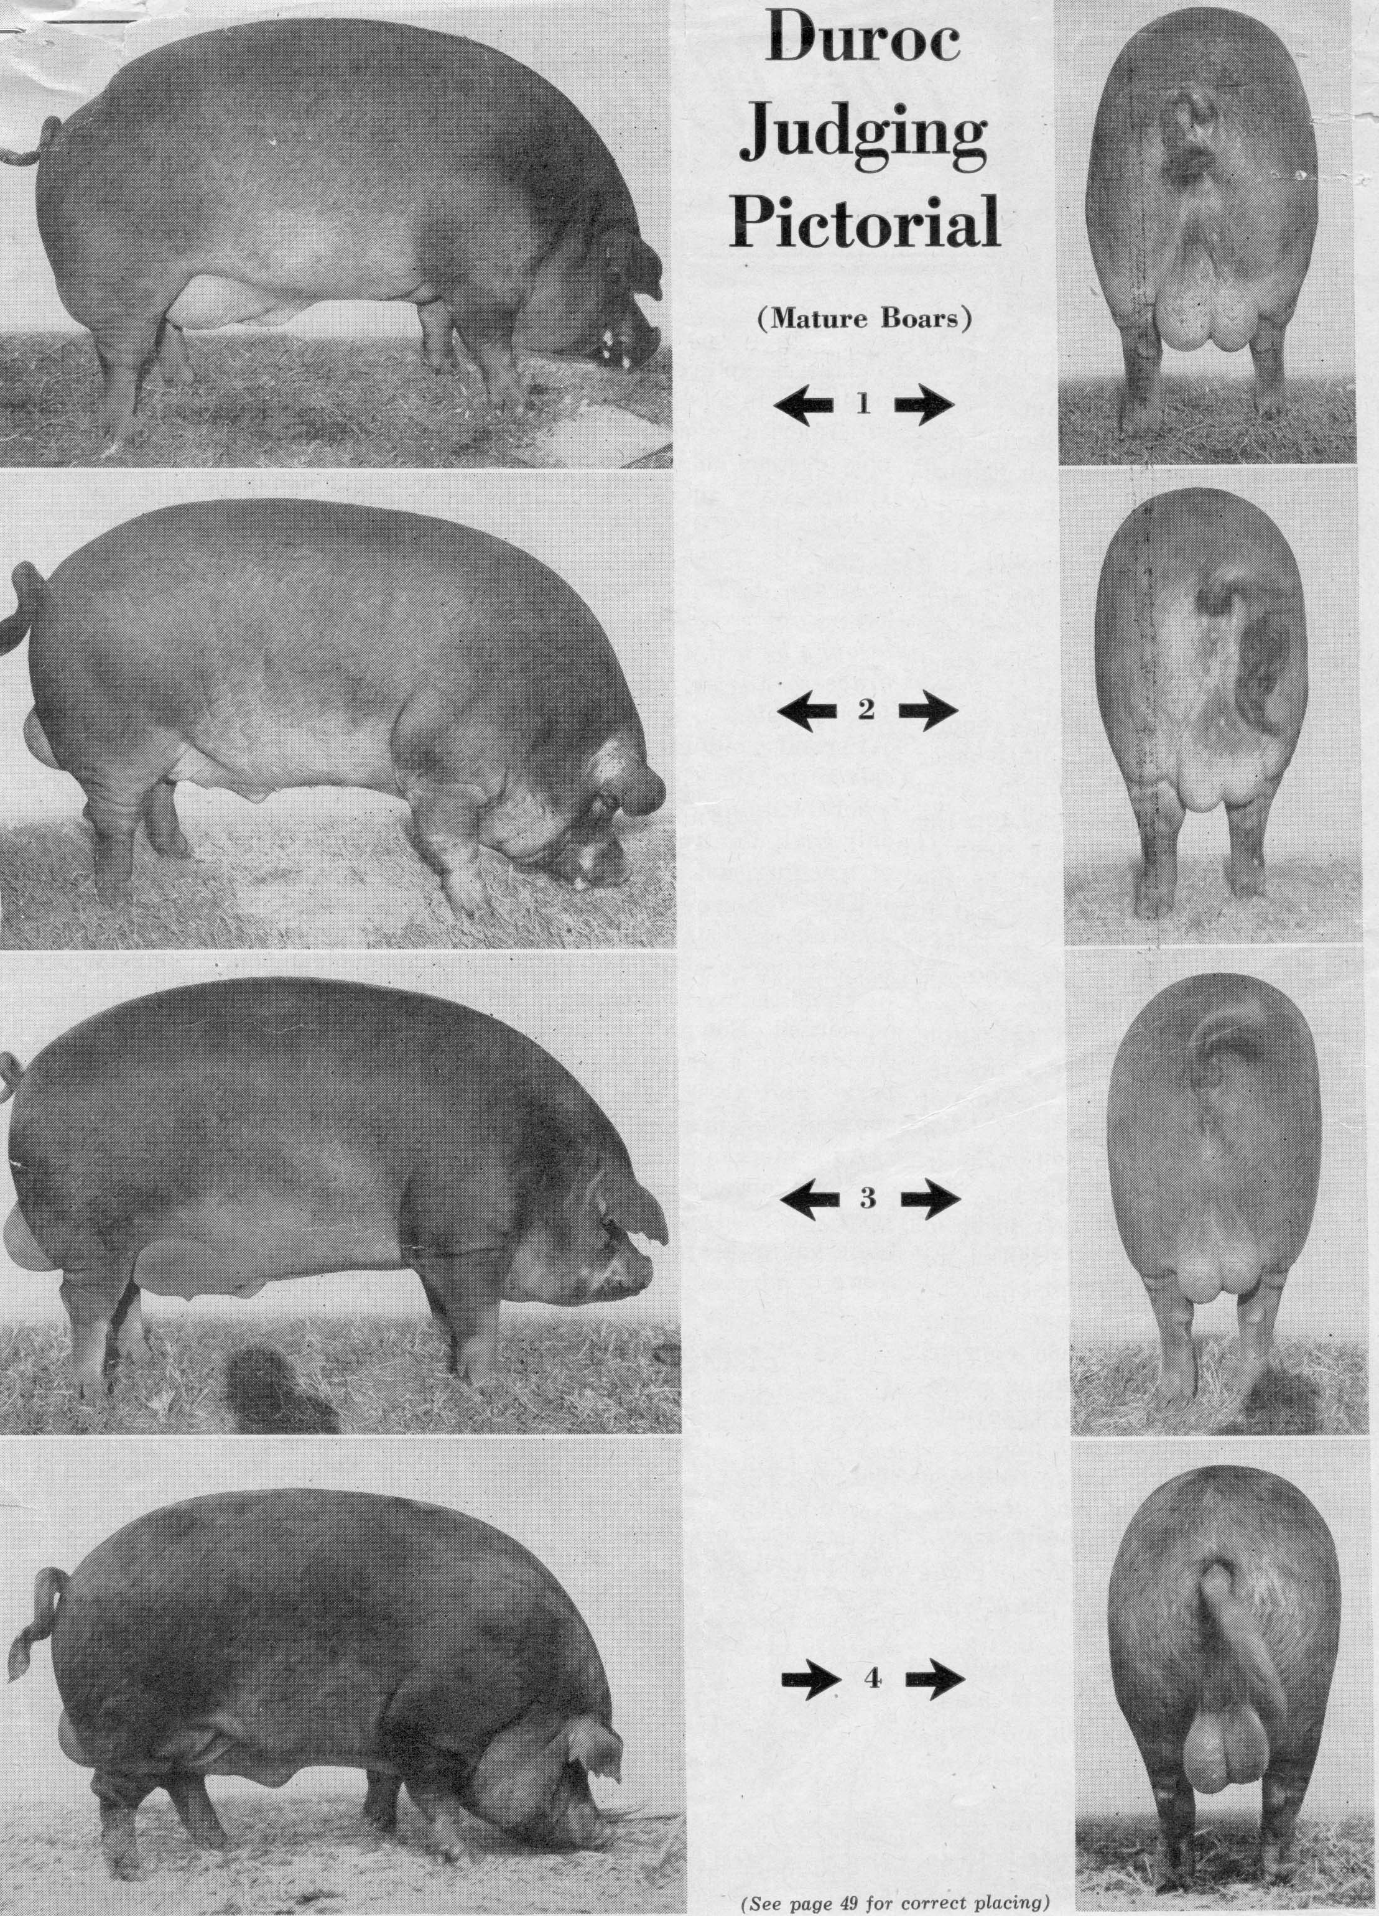
Duroc Boars
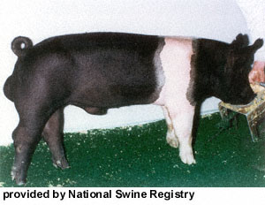
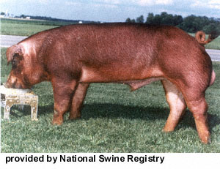
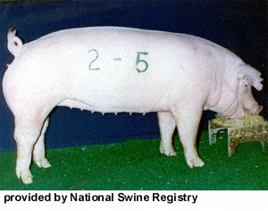
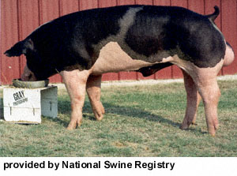
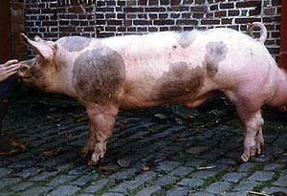
Current Pictures

