Mixing Feed
Finding and Using Ratios, Absolute Value, and Systems of Equations

Name: _______________________ Date: _________________

Introduction: Suppose you want 100 lbs of feed that is 15% protein. You have corn, which is 9% protein, and soybean meal, which is 40% protein, to mix to make the feed. How many lbs of each the corn and the soybean meal do you need to make the feed?
Part A
Solve this problem using Pearson’s Square (Instructions below):
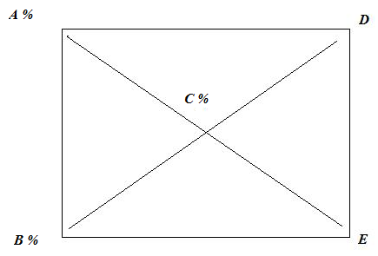
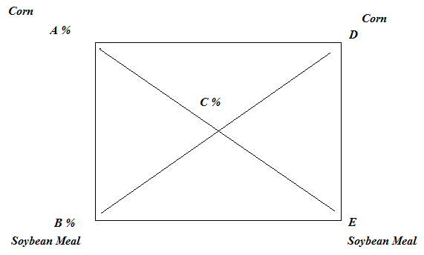

Pearson’s Square is a method for blending mixtures. Pearson’s square is often used in agriculture as a simple way to determine how much is needed of two things (such as feed) in order to create a blend with the appropriate percentage of a certain nutrient.

In order to use Pearson’s Square, you must know the percentage of the nutrient (protein) in the two types of feed (corn and soybean meal) and also the percentage of protein desired in the final mixture.
A represents the percentage of protein in the first type of feed, corn. Therefore, A = 9 %
B represents the percentage of protein in the second type of feed, soybean meal. Therefore, B = 40 %
C represents the percentage of protein desired in the new mixture. Therefore, C = 15 %

Once you have A, B, and C defined you want to find D and E. These represent the “parts” of each type of feed that you need in order to create the correct mixture.
D represents how many parts corn needed and E represents how many parts soybean meal needed.

To find D and E you must subtract diagonally and take the absolute value, in other words,
│A – C │ = E and │B – C │ = D

Determine D and E.
D = _________ E = _________

D + E = _________

What does D + E represent?

D and E represent the parts of corn and soybean meal. To determine how many pounds of corn and soybean meal we have to set up ratios. Since we want a total of 100 pounds of the new mixture we can use this to determine how much of each type of feed is needed. To determine the pounds of corn needed, x, use the following ratio:

D = x
D + E 100
x = ______ Explain why this ratio works. Look at what the numerators and denominators each represent.

______________________________________________________________________________________________________________________________________________________________________________________________________

Now set up a ratio to determine the pounds of soybean meal, y, needed.

y = ______

What should x + y = ?

Part B
Using systems of equations to blend mixtures.
Another way of blending mixtures is to set up a system of equations. A system of equations is a collection (more than one) of equations involving the same variables.

Set up a system of two equations using the variables x and y, where x = pounds of corn needed and y = pounds of soybean meal needed. Then, either algebraically or graphically, determine x and y.
(Hint: Let one equation represent the total pounds needed and then let second equation represent the percentages of the total needed.)

Part C
Write a paragraph explaining why it is beneficial to know more than one way to solve this type of problem.
KEY
Part A
D = 25
E = 6

D + E = 31

What does D + E represent?
The sum of the parts.

x = 80.64 lbs

Explanation: This ratio works because D + E is the sum of all the parts and 100 is the total amount of pounds. So by taking D/(D+E) = x/100, we are finding the portion of pounds that x needs to be.

y = 19.35 lbs

x + y = 100

Part B
Step 1
Define variables, to simplify, use the same variables as with Pearson’s Square.
x = pounds of corn
y = pounds of soybean meal

Step 2
Come up with the first equation. To do this you must look at what you know about the two types of feed and the final mixture. Let your first equation represent the pounds

(1) x + y = 100

Step 3
Come up with the second equation
We know we need a 15% protein feed, so how many lbs of protein need to be in the 100 lbs of feed? .15 x 100 = 15 lbs of protein.

(2) .09x + .40y = 15

Step 4
Solve (either algebraically or geometrically)

x = 80.64 lbs
y = 19.35 lbs

