IMPORTANCE OF ANIMALS TO AGRICULTURE

A Source of:

- Clothing
- Food
- By-products
- Recreation
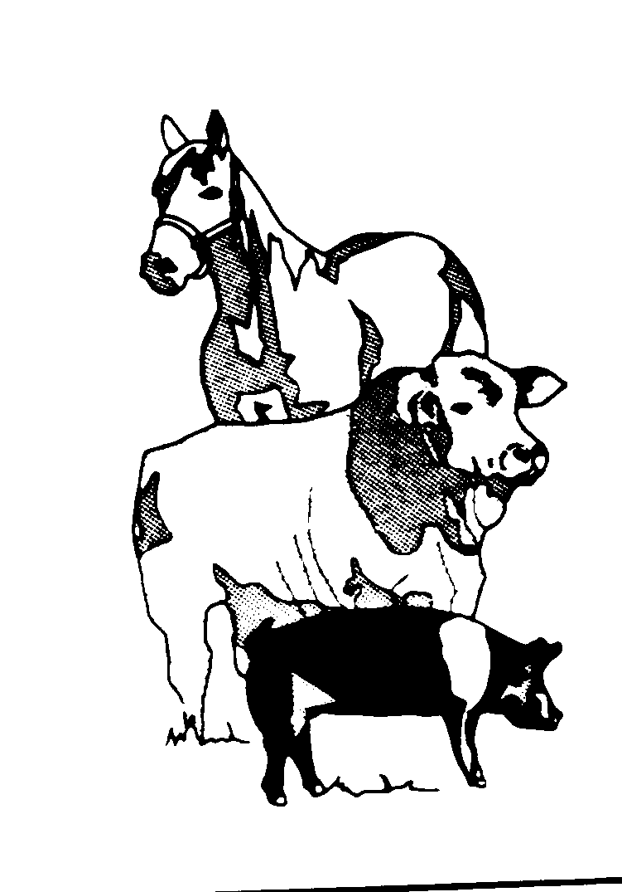
- Money
- Power

